xapkohheh
vimeo, patreon
in 1.0.1
If you would like to participate in the editing, pleasedraft

Preface
The purpose of this article is to explain in detail the basic principles of operationDOP-the context. Here you will not find a description of how to set up simulations, instructions on how to assembleCustom Smoke Solver, or explanations for each tool or node.

For a comfortable understanding of this material, it is recommended to have basic knowledge of Houdini andDOP-context and have some experience working with standard presets andShelf ToolsThe information was taken from official documentation onHoudini And HDK, and the blank spots are filled in by theories supported by experiments.

The article is accompanied by examples. All examples will be presented in the formhpaste-links (like abcdefg@HPaste), you can find a guide on how to use this utilityHere, the plugin itself can be downloadedhere. If you already have it installedhpaste, but the links don't work - update to the latest version.

Most examples contain nodes fromOBJ-context and output data toconsoleIn Linux, this will be a window.terminal, from which Houdini was launched, a small window will appear in Windowsconsolesat the first withdrawal.
For your convenience, it is highly recommended to usePython ShellWhen opened, all output will be automatically redirected there.

To restart the simulation from withinDOP- network, without pressing the Reset Simulation button - select the nodeOutput, put the flag up and then immediately remove itBypass, then rewind the simulation to the first frame (even if it is already on the first frame).

DOP
So, let's get started.DOP-the context looks deceptively similar toSOP, but it works completely differently. A node graph in a dynamic context is an instruction for creating and processing objects and data that exist separately from the nodes and are only artificially attached to them.

DOPObjects with attached data and the relationships that connect them are the core working parts of a dynamic context. They exist within the simulation independently of nodes; information about their representation can be found in the tab.Geometry Spreadsheetwithin the context.

DOP data
To begin withLet's forget about DOP nodes(This section will not mention DOP nodes at all.)

Basic concepts

Simulation
A simulation in the DOP context is the environment in which data exists and is transformed. A simulation is divided into steps, usually with a fixed time increment, which we'll call timesteps (not frames, to avoid confusion, as a timestep may not be equal to one frame).
Simulation should not be thought of as an entity existing in one timestep and changing from timestep to timestep, from step to step.
The simulation exists outside the timeline, it is more correct to think that the timeline exists inside the simulation, and each timestep on the timeline is a root for storing references to additional data, this additional data in turn does not exist tied to time, and canparticipateIn data structures attached to different timesteps. Take, for example, data representing a constant gravity force or a static and immutable collider. Objects from different timesteps can have a reference to this data, meaning the data exists across timesteps in a single instance, but different objects within the same timestep, or the "same" object in different timesteps, can reference this constant gravity or collider.
At first this may seem like an overly complicated concept, but it will become clear that this definition makes simulation caching and data sharing easier to understand.

Data
DOP data is the fundamental unit of a DOP simulation. DOP data modifies itself and each other according to the rules it defines. Objects, Relationships, Solvers, Forces, Geometry (as understood by DOP), and volume fields are all different specialized types of DOP data, and they all share the same functional core.

Any data can store one or more "records" (DOP record), which are simple key-value tables, or dictionary, in which a key-value pair is called a field (yes, a little confusing with volume fields), the keys are regular strings, and the values ​​corresponding to them can be any of Houdini's basic data types (e.g. string, int, float, vector, matrix, array of these, etc.).
In addition to records, data can store a reference to other data, in which case this data is called sub-data.(sub-data)That is, we call data sub-data when we talk about it in the context of having a reference to it in other data. It is important to note that the name is not part of the data, the name belongs only to the reference to the data, and the same data can be a sub-data of different data under different names.
For example, the same geometry (and I don't mean the same geometry, but the same DOP data of the geometry in the simulation) can be attached to two different objects, while on one object it can be called, say, Geometry, on the second - ReferenceGeometry and used by these objects in different ways, without duplicating in memory.
(example:sppexegoqu@HPaste(insert this example intoemptyDOP nodu))
Note that although data as such does not have a name, some special specializations of data, calledroot dataObjects and relationships have their own names, attached to the object itself. This name is implemented by a special field in the object's main record.
However, an object, while still fundamentally data, can be attached to another object as subdata with a reference name unrelated to the object's name, while retaining its own name in its records.
This is a complex and useless trick, but still, from a technical standpoint, it can be an interesting example:
(example:sppuwodalu@HPaste(insert this example intoemptyDOP nodu))

This is what a simulation we are familiar with might look like:
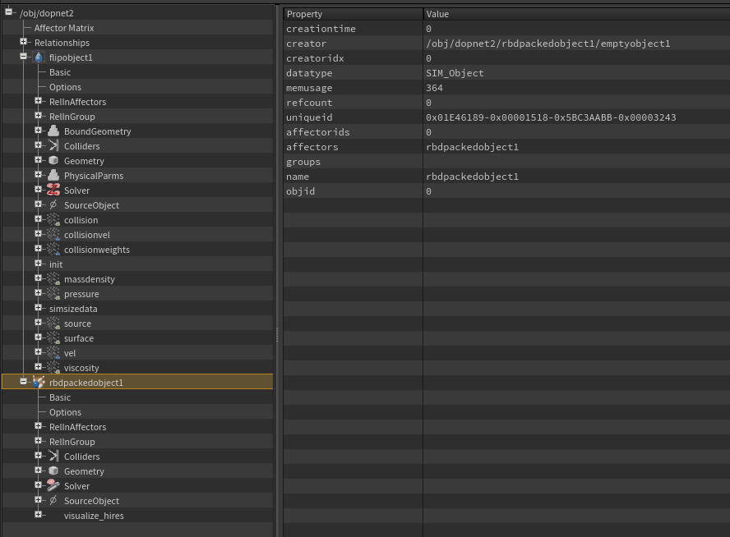
Let's quickly note here what is what:
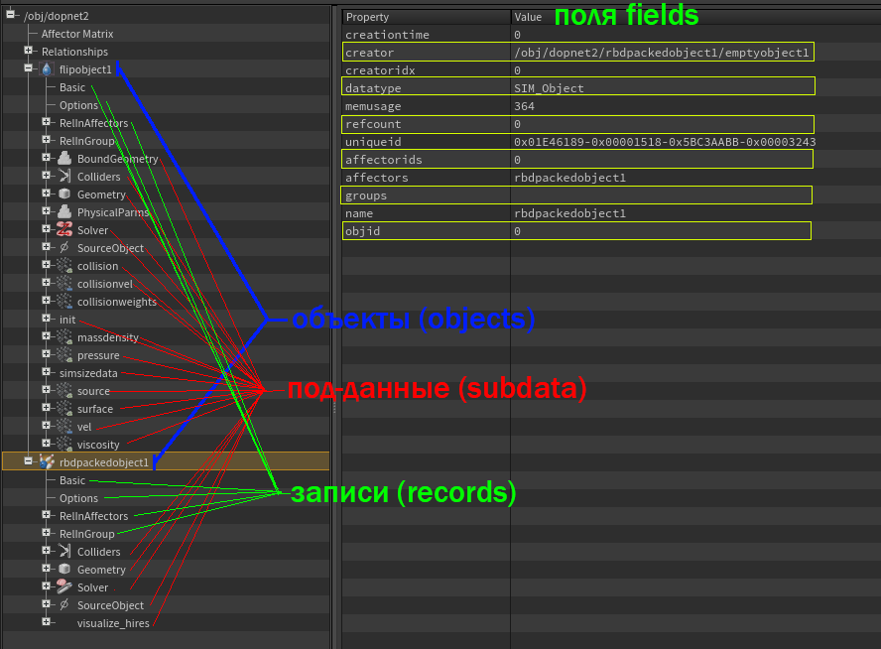
We can expand some data and see that it in turn has its own records and sub-data:
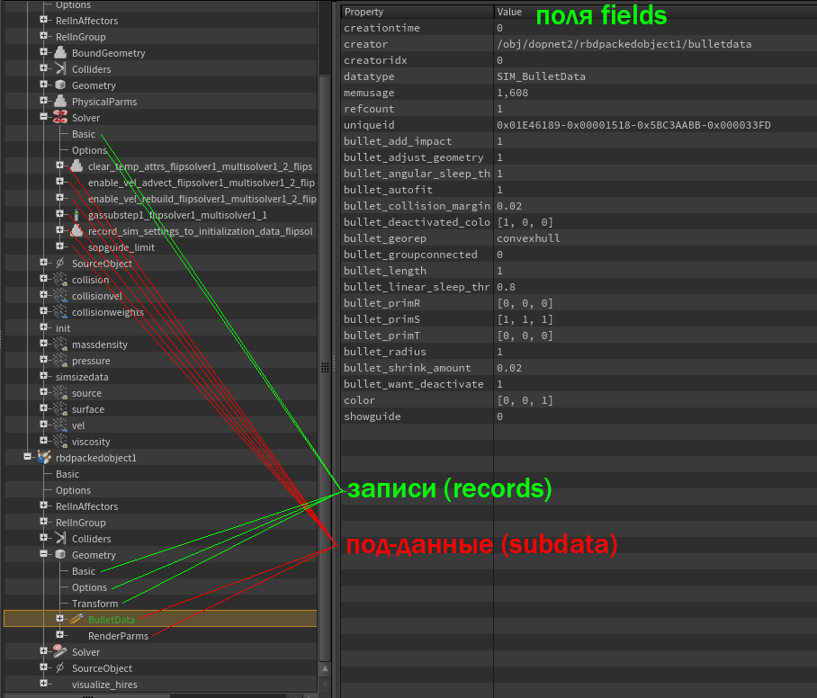
and such a data tree can be very large, for example the structure of a solver like flip, assembled from microsolvers, is nothing more than one big sub-data tree:
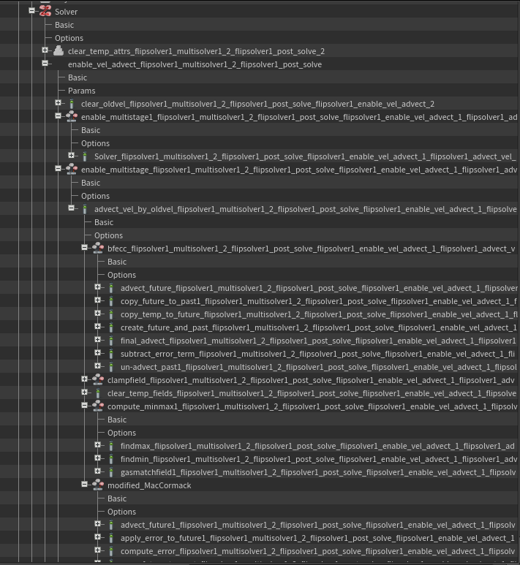
(These very long names were generated automatically when sub-data were attached, so to be unique within the object, this is not necessary; the names of references to sub-data only need to be unique within their parent data)

Unique identifier
All data, and therefore everything in the DOP simulation, has a unique identifier, uniqueid, it uniquely identifiesnot just dataNot only within a single timestep, but also across the entire simulation timeline, it is unique across different runs of the same simulation, and even across several different computers. This means that uniqueid is a truly unique identifier, and it will definitely never be repeated within a single simulation. Furthermore, it is extremely unlikely to ever be repeated. It can be found in the default Basic record for any data, and it can be used to reliably determine whether different subdata references point to the same data.
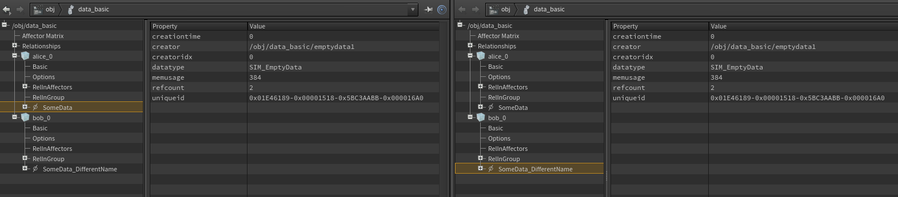
Notice that the different objects (alice_0 and bob_0) have data with different names (SomeData and SomeData_DifferentName), but in reality these are just different references to the same data (this can be seen by the same uniqueid displayed on both references.
In fact, the data structure looks like this:
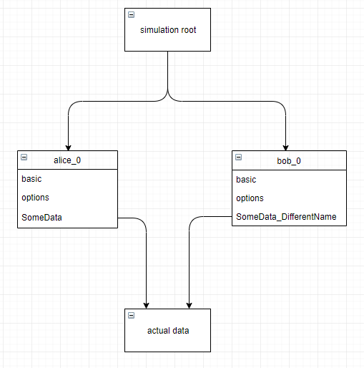
This example may seem abstract, but it's more common than you might think, for example, the default behavior of some solvers, such as Bullet, is to attach objects as common subdata (why some solvers attach this way by default will become clear in the chapter on the object solving stage):

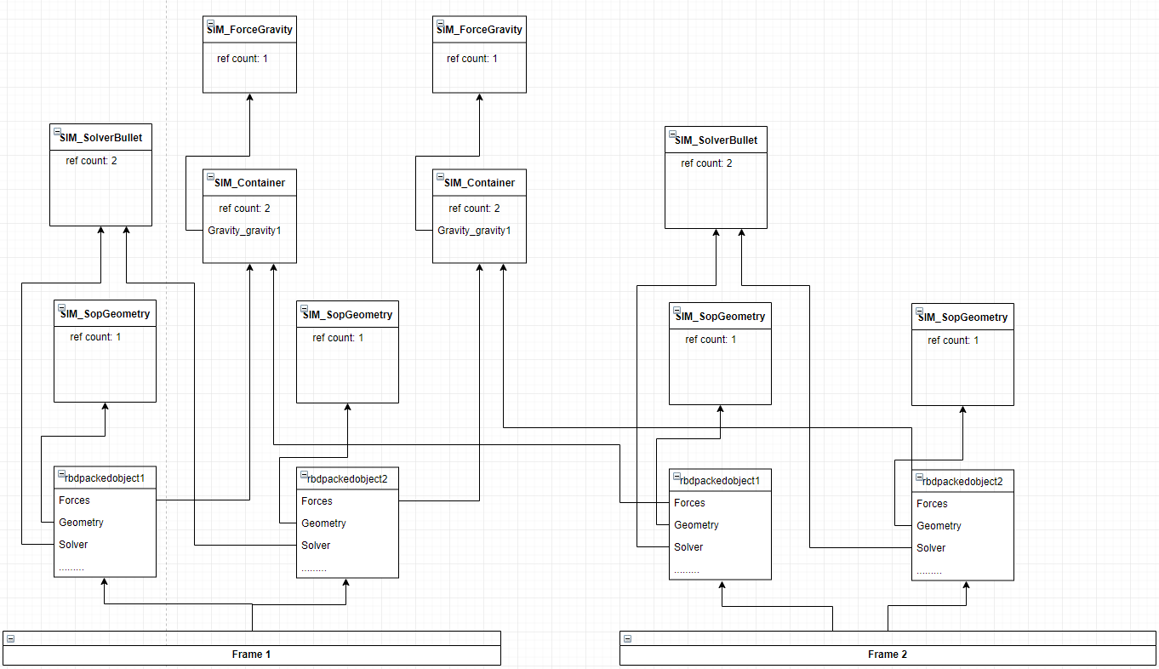
Link counter
The data in the Basic record has a ref count field, which stores the number of references from different data, i.e., how many times this data appears as subdata of other data, not only in the current timestep, but throughout the simulation. Gravity data can have a reference count of 100, even though there is only one smoke object in each timestep. This is because all 100 smoke objects from each frame actually reside in the simulation cache, and each of them references the same gravity data.

Data modification, COW principle
Another important and counterintuitive concept of DOP is copy-on-write (CoW) - if there ismore than onelink to some data, and some node is tryingchange this data by reference to sub-data (in the example below, the modifydata1 node is trying to modify the sub-data referenced by the EmptyData object bob), - the data will be copied, the reference to the sub-data will be changed to point to the new copy, and only then will the node be allowed to modify the data. The purpose of this approach is to prevent one object from inadvertently modifying the data of another object, or itself from a previous/different timestep, while maintaining the ability to have multiple references to the same data in memory, saving computer resources.
(example:sppocufatu@HPaste(OBJ context))
(There will also be an example of this process in pictures below)
The root data of a simulation (objects and relationships, which may not be attached anywhere, more on that later) belongs to a certain timestep and cannot belong to more than one timestep. A timestep can be said to store a unique reference to the object's data. Thus, in the case of a cached simulation, (old timesteps and all their data are stored in simulation memory) objects and relationships will be copied from timestep to timestep before they undergo any changes.
Relationships are copied to the new timestep automatically as long as their object lists are not empty. Objects must be copied to the new timestep explicitly, which will be described later in the discussion of object flow.
Every time you change data in a cached simulation (for example, the solver changes geometry, or an animated parameter on a node changes some field), a new copy of that data is created, so the old data (from the previous timestep) remains unchanged.Thus, when caching the simulationeach timestep will be an immutable, valid state of the simulation, which can be saved, loaded, and from which the simulation can be fully continued.
Note that in the uncached simulation data from previous timesteps is not stored, so there will be no references to objects from previous timesteps, which means there will be no extra references to the data of these objects, so the objects and data will have a reference counter of 1,AndData won't be copied when modified, so solvers can work on objects without copying objects or data. While this can save resources, if a solver requires the previous state of an object, for example, for interpolation, that solver won't be able to work. Furthermore, from a usability standpoint, the user won't be able to quickly navigate the timeline interactively and analyze the simulation state..

Let's look at how data is copied during a simulation using a simple, everyday example.
Initial state of the simulation:
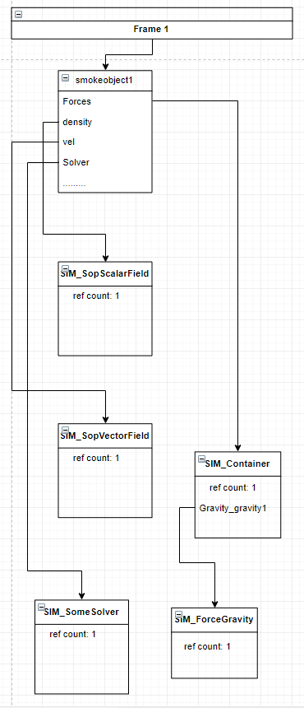
Now on the next timestep the following will happen: the object (cached simulation) will be copied, keeping references to all sub-data from the previous frame

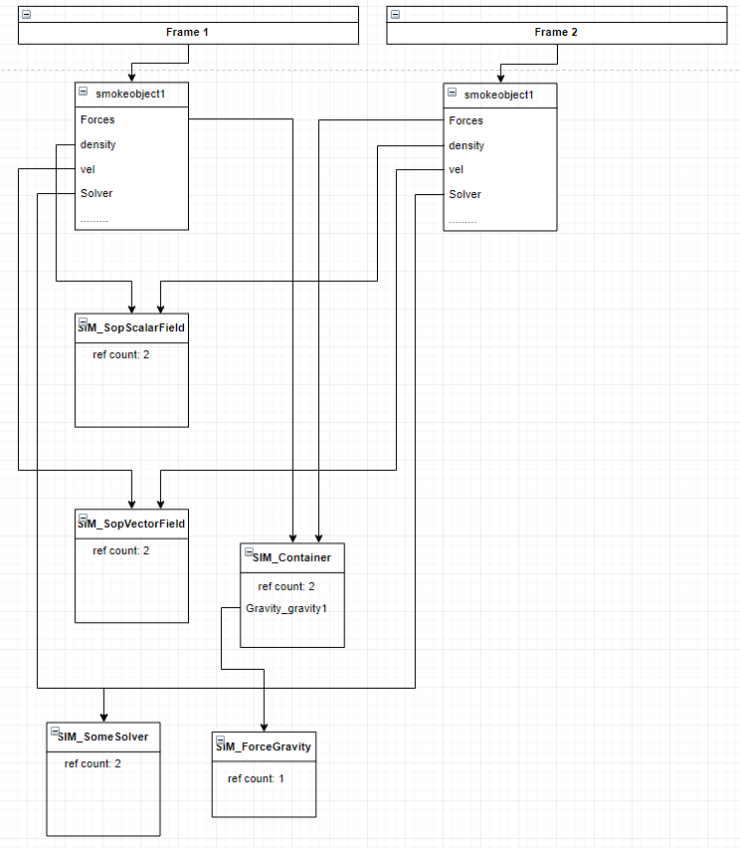
Then, depending on the simulation logic, if anything changes this data—for example, a smoke solver changes all fields—the changed fields will be written to the new data, and the reference to them will be updated on the object. (In most cases, running the solver functionality (except for a static solver, which does nothing at all) is considered a change to the solver data, so it is copied.)

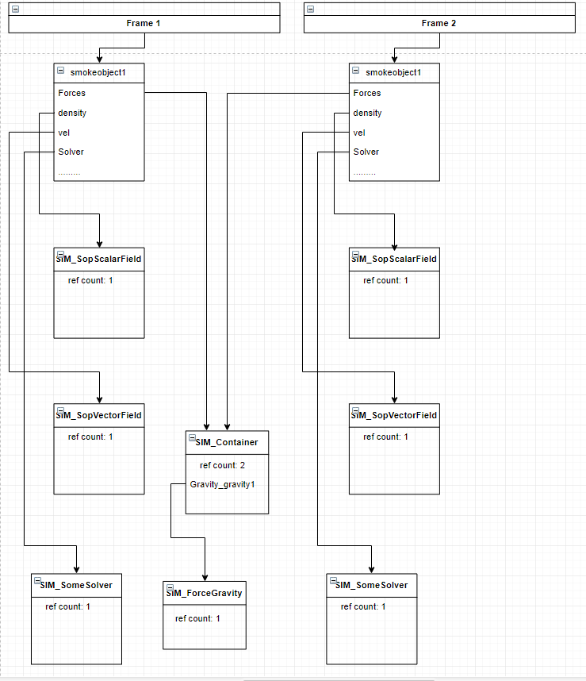
Data that hasn't changed, such as gravity, which we left constant by default, will remain the same, it won't be copied, and the reference to it won't change.
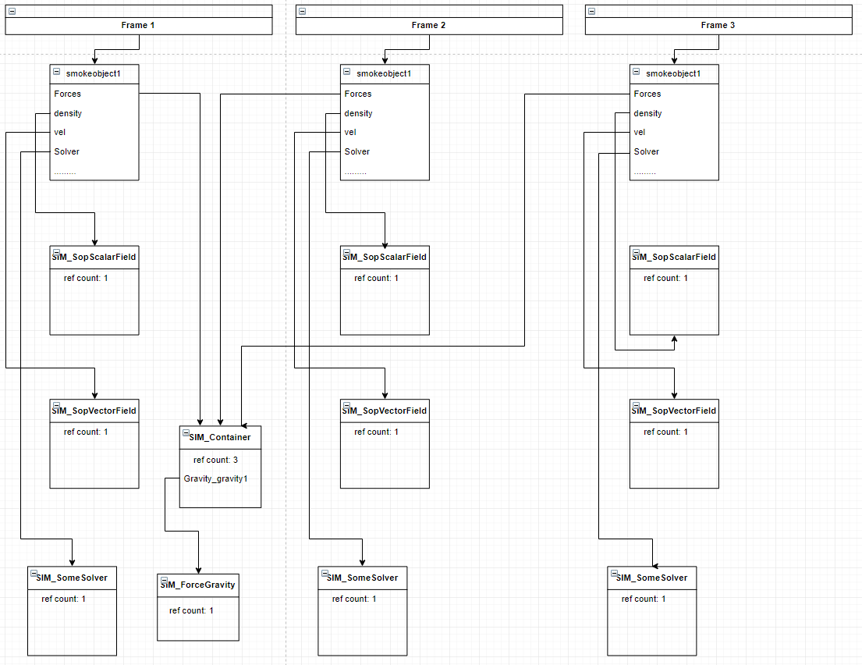

In the case of a single solver for several objects, as, for example, in the default setup with a bullet solver, the data schema will look like this:
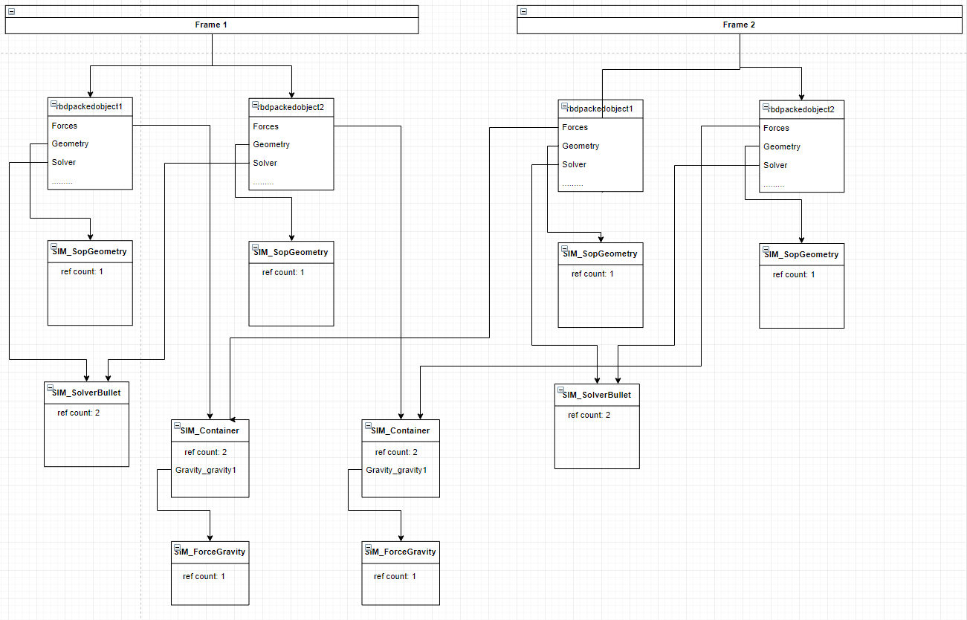
(Note that even though the same force is attached to the objects, the default setup will still create separate force data for each of the objects)

So, what types of data are there, what do they represent, and what do they do? This question is difficult to answer, since, apart from certain specific types of data,(e.g. objects, solvers, relationships)Houdini's simulation engine doesn't know and doesn't want to know what exactly the data is, why it's needed, and who needs it; it doesn't differentiate between them.
Data is specialized for specific tasks by programmers. For example, for particle and RDB simulations (and many other things), geometric data (geometry) was written (essentially a wrapper for regular SOP geometry); for gas and liquid simulations, data for vector and scalar meshes, all kinds of visualization data, constraints, and, of course, hundreds of different primary and secondary solvers.

Basic data types
Let's talk separately about objects, solvers and relationships.
We briefly touched upon the features of the objects:

Objects
Objects are the central data type. Only objects and relationships can be root data and exist without being attached to other data. Therefore, an object can be viewed as a framework onto which data of various types is attached, and since all specialization goes into the data types attached to the object, there is no point in specializing the object itself.,looking into any simulation, You everywhereyou will see the same object data type.
An object belongs to a single timestep, so in a cached simulation, Houdini will copy objects every timestep, even if no changes have occurred on the object itself yet.
Houdini recognizes and uses the name field in their Basic record to display and search for an object by name, in addition, each timestep Houdini updates the lists of relationships in which the object participates and specially processes data with the Solver reference name.

Relationships
Relationships are a special data type that, like objects, can be rooted. The main purpose of relationships is to tell Houdini which objects influence which others, so that during solver execution, Houdini can group the objects and choose the correct solving order.
A relationship maintains two lists of objects: those that influence and those that are influenced. As soon as objects are added to one of these lists, Houdini tracks this and adds a record to the object with the name of this relationship for easy tracking. It's worth noting that relationship specializations, like objects, occur not through inheritance of the relationship class itself, but through the attachment of specialized data—relationshipData subclasses of auxiliary data—that are attached to the standard relationship data and define its behavior. For simplicity, in what follows, I'll refer to relationship specialization as the specialization of subdata on relationships.
There are many specializations of relationships, such as collide relationships, source relationships, pump relationships, constraint relationships, groups, and so on. Their purpose is to supplement the basic functionality of relationships with specialized features and distinguish this type of relationship from others. For example, solvers can check whether an object is in a collide relationship with another object, retrieve a list of these objects, and then react as desired. A solver isn't required to search for a collide relationship to find a list of colliding objects; this is entirely up to the programmer writing the solver. They can use a pump relationship, write their own relationship, or not support relationships at all but have a parameter with a list of object names.
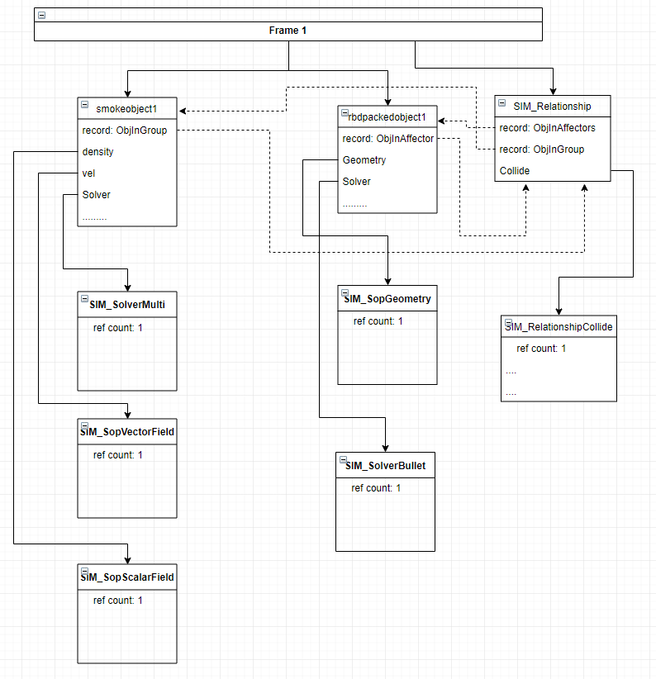
PHoudini constructs a dependency graph from the set of all relationships and decides which objects to resolve in what order. (More on the solving order later.)NYou can see some representation of object dependencies in the Geometry Spreadsheet tab in the DOP simulation, in the Affector Matrix pseudo-table, where the color indicates how an object from a column affects an object from a row. By hovering the mouse over a table cell, you will see a tooltip about this.

Solvers
Solvers- This is another special core data type. Solver data, in addition to storing information, also has functionality that Houdini knows how to execute.
One of the stages of simulation at each time step is the solving process.. Gudini, according to the constructed graph of object dependencies (more details will be in the chapter on the Solving Stage), searches for data with the name Solver on each of them (yes, the search is performed by the name of the link to the sub-data), Andif this data is of type SIM_Solver or its derivatives, ThatThe Houdini simulation engine will run the functionality (let's say "run the solver" or "solve the object") programmed into that solver. What this functionality will do is known only to the programmer; the possibilities are essentially limitless.. TTraditionally, the solver is fed with the objects to which it is attached,after whichhe finds or creates the data he needs on them and changes it.
For example, the bullet and pop solvers will search their objects for data with the reference name "Geometry," while the smoke solver will search for a whole range of data, such as the scalar field "density" and the vector field "vel," etc. There is also a whole range of microsolvers and auxiliary solvers, which will be discussed in the chapter "Solving Stage."

Less important basic data types

Forces
Forces are one of the most frequently encountered data types. All forces have a convenient common functionality that allows you to query the force to calculate the applied force for a number of common situations, making them a convenient general mechanism for introducing physical forces into a variety of simulations.
Solvers may or may not request and use forces for their calculations, just as they may or may not follow the recommendation of the selected sampling mode.

Visualizers
Such as ScalarFieldVisualization, VectorFieldVisualization, ConstraintNetworkVisualization, and many others, mostly with the word "Visualization" in the data type name. This data should typically be a subset of the data being visualized, which is logical for visualizing individual data. However, composite visualizers visualizing combined data will reside elsewhere, for example, on the same parent as the data set being visualized. This is all individual and depends on the specific visualizer, as visualizers share only a common semantic purpose, with no hard and fast rules.
DOP has a mechanism that allows arbitrary data to be used to create views for the viewport. For example, this mechanism allows geometry from SIM_Geometry to be displayed in the viewport. However, visualization is often separated from the actual data to allow for a convenient and simple way to change the visualization based on user preferences or the simulation's design, and to avoid overloading the payload data with a ton of additional, repetitive functionality.
For example, there's a scalar field, SIM_SopScalarField, which isn't displayed in the viewport. However, we can attach SIM_ScalarFieldVisualization data to it and visualize the data from SIM_SopScalarField using various methods implemented in SIM_ScalarFieldVisualization. Or, instead of an individual field visualization, we can use a single SIM_MultiFieldVisualization dataset, which, taking into account data from multiple fields at once, can display a more accurate data representation in the viewport. For example, it wouldn't be informative to look at density, temperature, and heat separately, each visualized by its own visualizer, but it's convenient to see a multi-visualization where smoke density is derived from density and heat, and temperature is responsible for color.

Empty Data
The simplest basic data type (the only simpler one is SIM_Container, which serves exclusively as data for storing links to other data and does not even have an options entry)
Empty data is convenient for creating custom fields and storing arbitrary information in them. These could be floats, strings, or arrays, which, for example, are needed for your own custom solver script.

Now that we have a more or less general idea of ​​how the DOP contest works with data, let's return to the simulation itself and finally see how the nodes correspond to the data.

General structure of simulation calculation
A simulation in a DOP context is the environment in which data exists and is transformed. A simulation is divided into steps, typically with a fixed time step (timestep), which can be specified on the DOP simulation node; by default, the timestep is one frame.
Each step of DOP simulation occurs in 2 stages:
- Node graph computation stage
- Solver computation stage (solving)
It is important to remember that these two stages occur strictly sequentially and do not overlap, so at the node calculation stage, no information about the solving of a given timestep is available, even if the solver was created by the currently calculating node, just as at the time of solving, no intermediate stage of node calculation is available - they have all already been calculated, all new data has been created, the order of solving objects has already been built and cannot be changed for the current timestep.
Let's consider these stages:

Node graph computation stage
Further, when speaking about nodes, we will separate objects from other types of data, and when using the term "data" we will mean only non-object data and not relations, while we will call object data simply objects, and relational data - relations.
We will also count the inputs of nodes withfirst, NOT from scratch. usually the node inputs will be divided simply into the first and the rest.
The purpose of a DOP node is to create, delete, or modify objects, relationships, and other data in a DOP simulation.
It is worth noting that there are 2 types of additional node connections: object flow and data flow, they are distinguished by color in the network editor.

Traversing a node graph
Please note: the graph traversal examples contain scripted parameters on nodes that are calculated during the graph traversal stage. However, if any node is selected in the viewport, its parameters will be additionally calculated for the display after the graph traversal, creating additional console output, which can be confusing. Therefore, always either deselect all nodes during testing, or select the Output node (it never has expressions), or monitor console output exclusively outside the additional network.
The calculation of the node DOP occurs in a strict order determined by traversing the node graph along object connections in depth (bottom-up in Houdini) from the node marked with the Output flag.
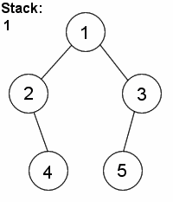
(In the image above, the node with the output flag is node 1. Note that this graph is drawn "down" from the root, while the additional graph is drawn "up" from the root. The node's functionality is executed when the node turns green.)
However, there are a number of nodes that define the structure of the graph itself, such as switch (Notswitch solver), merge, apply data, their execution occurs in a special way, not according to the rule of depth traversal, usually at the first encounter during traversal.
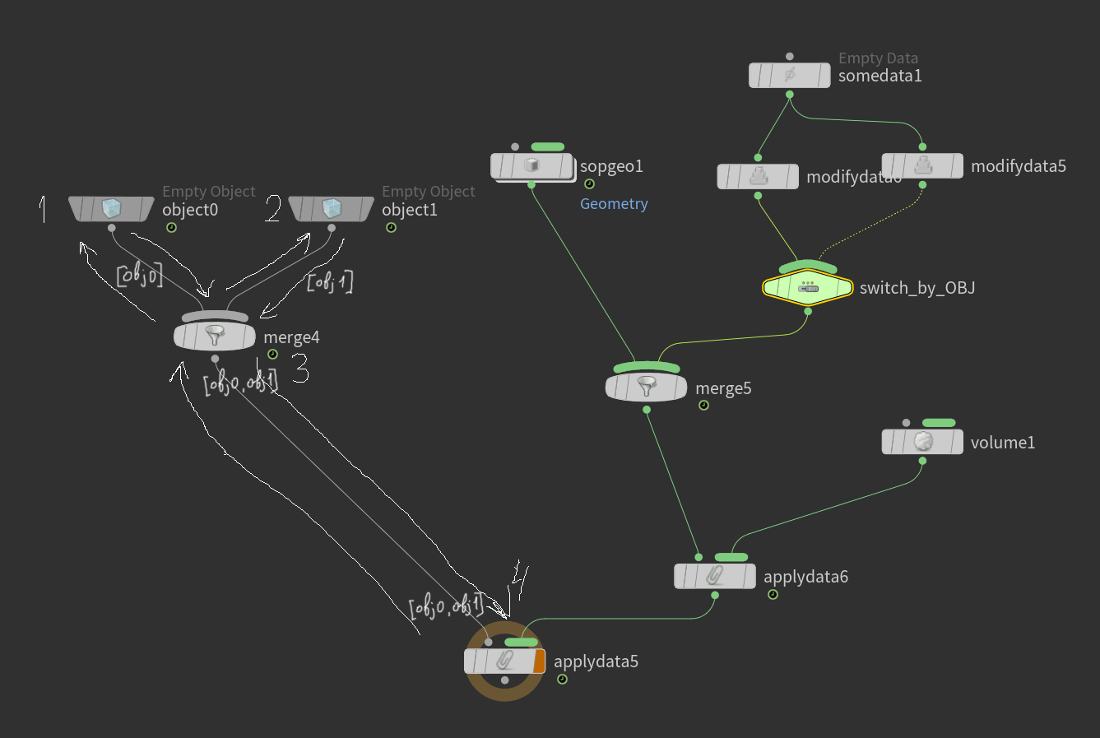
(The numbers in the image indicate the order in which nodes are executed. Note that while the merge4 node's relationship creation functionality will be executed third, its activation parameter will be calculated the first time the node is encountered, i.e., before the object0 functionality is executed. As we've already discussed, this parameter determines the very structure of the graph traversal, just like the switch nodes. If activatino evaluates to 0, the graph traversal will not proceed to the object1 branch.)
Object connections transmit data from node to node.list of linksto simulation objects (it is not the object data itself that is "transferred", but only references; the data itself exists outside the nodes, in the simulation itself)
by data connectionsusuallya list of references to other, non-object, data flows, but their calculation occurs a little differently
By "Execution" or "Work" of a node is meant the execution of the functionality embedded in the node on the list of objects fed to it, directly (list of object stream) or indirectly (current data, local data list (see data stream below))

Stream of objects
Let's talk first exclusively about the object flow
You can see that any chain of object connections starts with an empty object node.

The object node (empty object) calculates its activation parameter, and if it is non-zero, it repeats the number of times equal to the number of objects parameter, does the following: creates a new object, calculates the object name parameter and the remaining two checkboxes, and applies these parameters to the created object. Note that for newly created objects, the creator field in the Basic record contains the path to the node that created the object - this is one of the key waysdata become attached tosad.
Next, all objects in the simulation that belong toprevious timestep, and those whose creator field matches the path of this empty object node are copied with all their references to sub-data (according to the previously described CoW principle) to the current timestep (as stated earlier, each instance of object data belongs to one specific timestep, so "copying to the current timestep" means copying the object and writing a reference to it to the current timestep). It is the nodeempty objectis responsible for copying objects from the previous timestep into the current one - a process that was discussed earlier.
If a node specified in the creator field of an object's Basic record was not reached during the node graph traversal in the current timestep, that object will not be copied to the current timestep from the previous one.
(example:sppehewuqe@HPaste(OBJ context))
Now references to objects copied from the previous timestep and newly created objects are written to the object stream and passed to the next node downstream.
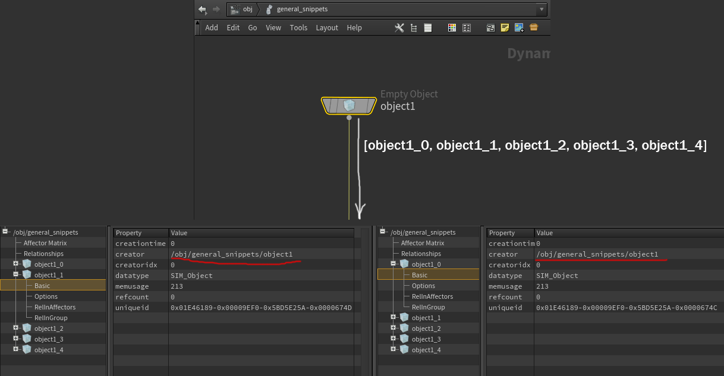
The object creation node is executed once per graph traversal. If we come to this node again during the graph traversal, it will skip the stage of calculating parameters and creating objects and immediately return the list of objects, the same one that it returned earlier through another connection.
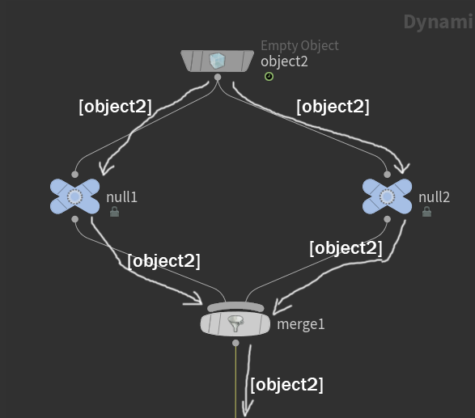
Note that the object stream "passes" a list of references to objects, not the objects themselves, so in the screenshot above, the object is not duplicated, but duplicate references in the list will be merged, so below merge1 object2 will NOT be processed twice.

Further along the object flow, you may encounter nodes such as:
auxiliary: null, merge, switch
data modification nodes: modify data, delete
data nodes or apply data

Let's take a look in order.
- Nodaswitch (switch) (not to be confused with a switch solver) serve only to determine the structure of the graph being traversed. Their parameters are calculated at the first encounter (i.e., moving from bottom to top), determining how the graph traversal proceeds. Apart from this, the node has no effect on the simulation.
- nodanull (null)- does nothing
- Nodamerj (merge) - unites the lists of objects included in it (duplicate entries are excluded), also, for convenience, it has the ability to create relationshipships between the object streams included in it: in the mutual mode, a relationshipship of the specified type will be created, including all input objects in both the affectors and the affected lists (all objects mutually influence each other), in the left inputs affect right mode, one or more relationshipships will be created, reflecting that all objects from the first input of the merge affect the objects of all inputs to the right, then the objects of the second input of the merge affect the objects of all inputs to the right of the second, and so on. The merge node's activation parameter will also be calculated at the first encounter (i.e., when passing from bottom to top), and if the parameter evaluates to zero, the node will do nothing, only pass the list of objects from the first input further down, the remaining inputs will be ignored (although the help says that activation only affects whether the relation will be applied or not, and the lists of objects will be merged anyway - but tests show that this is not the case)
- Data modification nodeswork on the same principle: for each of the objects, one ofincoming listThe node's parameters will be calculated, and the corresponding node-defined operations will be performed. For example, for "modify data," this checks whether the object belongs to a group, finds the specified data on it, and performs a series of modifications to the fields in the Options record. For "delete," this deletes the specified data from the object or removes the object itself from the simulation (and, of course, also removes it from the object flow list). (Note that only the current timestep's copy of the object/data will be deleted; copies of the object belonging to other timesteps will be fine.)
- apply dataThis is a very special node in the graph structure. It might seem like it has more than one input, so according to the depth-first traversal rule, the subgraph of the first input should be traversed and executed first, then the second, and so on, and only then should the apply data node itself be executed. But this is not the case. In fact, the apply data node connects several independent node graphs: the graph of the first input, and each individual graph of the remaining inputs. It is part only of the graph of its first input; all graphs of the remaining inputs are, so to speak, parameters of the node. So, as soon as the traversal of the subgraph of the first input is complete and we return to the apply data node, it will be executed.
In the previous example, the node applydata5 will actually be executed 4th in a row, the subgraph starting with the node applydata6 is, so to speak, a parameter of the node applydata5, and its calculation is partfunctionality performedapplydaya5 nodes
The functionality of the apply data node is to execute each of its non-primary subgraphs for each data entry at the first input (more details below). So, in the image above, two objects are listed at the first input, meaning one of its non-primary subgraphs, starting with applydata6, will be executed twice, once for each object.
It is also worth noting that the activation attribute of the apply data node is calculated for each object/data from the first input list, for each subgraph of a non-first input. i.e., in the example
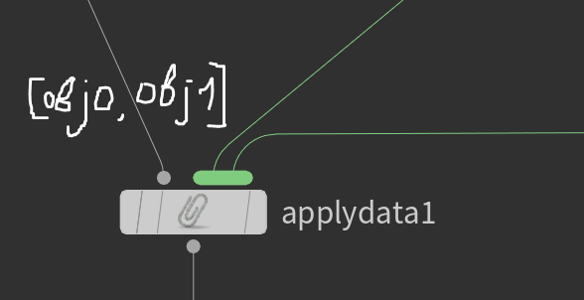
The activation parameter of the applydata1 node will be calculated 4 times: for each of the objects obj0 and obj1 for each of the second and third inputs.
Let us just note that the order of execution of the subgraphs is as follows: each graph of the non-first input is executed for each object/data of the first input. i.e., in the example above:
1) input subgraph 2 for obj0
2) input subgraph 2 for obj1
3) input subgraph 3 for obj0
4) input subgraph 3 for obj1
The operating principle of apply data will be discussed in more detail later in the data flow.
(example:sppodazeki@HPaste(OBJ context))

Data nodes
As a rule (this is not a hard DOP rule, but rather a guideline), for each data type there is a node whose job is to create that data type.
(e.g., Sop Geometry, Sop Vector Field, Bullet Data, all solvers). These nodes can be included directly in the object flow or connected via the apply data node—both of these methods are simply different ways of expressing the same process.
You may notice that there are data nodes with a single object input:
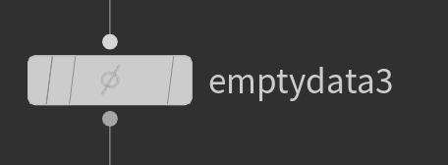
or nodes with one object input and multiple data inputs
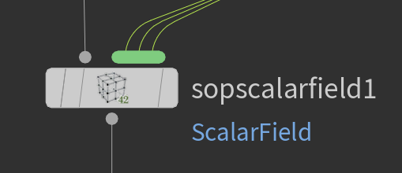
The principle of their connection into an object stream is equivalent to the following diagram with the apply data node
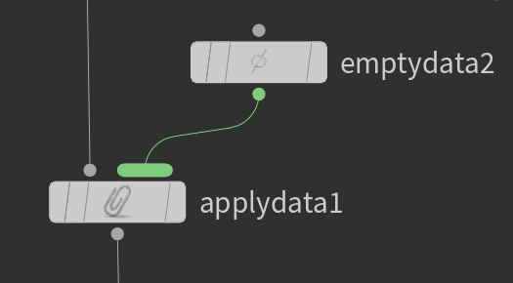
And
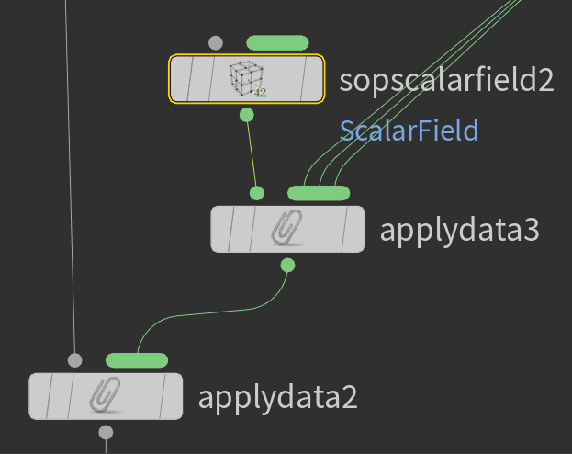
respectively.
We won't pay special attention to multiple data inputs on data nodes, as they can be brought into a common pattern using apply data, as shown in the figure. (The only difference between connecting data via apply data in the last and second-second-last figures is that in the second-second-last case, the data can tell the graph crawler what types of data it expects to see and issue a warning in the case of an unexpected subdata type. However, this will not affect the graph's operation or the structure of the generated data.)

Data flow
We will only consider the method of attaching data through the apply data node due to the equivalence of the attachment methods (described just above).

I've tried to come up with the simplest way to describe the process of calculating and appending data, while sacrificing as little detail as possible, so the following description may be a bit overcomplicated.
Unfortunately, in the process of computing the node graph of the DOP context, there are a number of special cases that make a simple and understandable description of its operation in detail difficult.

So, the apply data node (its first input can include either an object stream or a data stream) operates similarly to the copy stamp node in the SOP context: the subgraphs included in the data inputs are calculated sequentially for each data or object in the list from the first input. That is, from the list of objects or data coming in the first input, the next element in sequence is selected one by one. We will say that this next element (data or object) is defined ascurrent parental datato compute data subgraphs (not the first input) on the apply data node.
Ifcurrent data- an object, then, as usual for an object flow, local variables $OBJ $OBJID $OBJNAME are set (they are set "globally", just like for any other node in the object flow) and other variables associated with the object. We will say that the reference to the object is saved ascurrent object, that is, the object will be andcurrent data, And current object.
If current data - non-object data - nothing will happen except for setting the current data, that is, set local variables of the type $OBJ $OBJID $OBNAME andcurrent objectwill remain untouched.
Once again, for each computation of each subgraph, the following will be specified:
- current data
- local variables associated with the object ($OBJ $OBJID $OBJNAME $OBJCT $OBJCF)
- current object- initially equal to the current data, but not changed by subsequent apply data nodes in the data stream.
You can also combine the last two points, the point being that when traversing non-primary subgraphs, information about the object for which the data flow subgraph is calculated is always stored.
Comment:In this section, we won't discuss attaching data to relationships, to avoid complicating the already complex explanation. The logic will be generally the same, but relationships will have different local variables and will not have a current object.

TNow, with the givencurrent dataand other information, all nodes in the subgraphs of the non-first input apply data are calculated depth-first, in the same way as the object flow traversal was calculated, also with the calculation of all switches during the pathfinding (when traversing from bottom to top). Next, during the recursive depth-first traversal, there are two very different graph behaviors. My personal opinion is that this is a bug, and no one has fixed it for years, because such complex structures in the DOP graph are rare and can always be reassembled into simpler ones. So, if another apply data node is not encountered during the subgraph traversal, then the calculation is performed in a manner similar to the object part: the graph is traversed depth-first, all switch nodes calculate their input at the first encounter in the graph, the nodes are executed on the incoming data list, and if they create data, it is immediately attached tocurrent dataAs sub-data with the required reference name, they are added to the input list and passed downstream to the next nodes. The merge node combines the lists of references from its input streams (no relationships are created and cannot be created for non-object data). We will call this type of operation -Normal

(IMPORTANT: The followingbrokenThe mode was fixed starting with Houdini 18.0, all information aboutbrokenThis mode is not relevant for Houdini versions starting from 18.0) the article requires updating
However, if, as we traverse the data flow recursively deeper, we encounter another apply data node, the graph computationher first entrancewill go in a very unexpected way. The calculation of the second and subsequent inputs will proceed in the same way as inNormal modeBut what about the first input? The order of execution remains the same, but the data flow is completely broken. Now, despite the graph's branching data connection structure, there is no data flow at all. Instead, the data list is shared by all nodes in the subgraph from this point on. Each node in the subgraph executes on this shared list, and references to newly created data are added to this list. This list exists for one traversal of the subgraph; on the next traversal, the list will be recreated. We'll call this listlocal list of subgraph data, and this version of work is -BrokenBecause of this brokenness, one can encounter very non-obvious, illogical, and unexpected results when calculating the graph, for example:
With such a node structure, the data subgraph will be calculated using the Normal method:
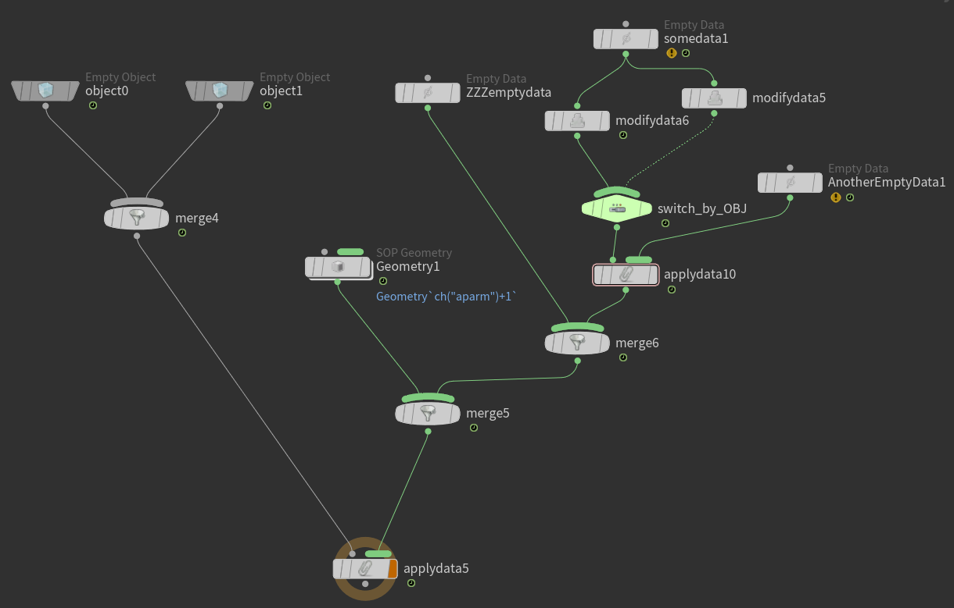
and the resulting data structure will look like this:
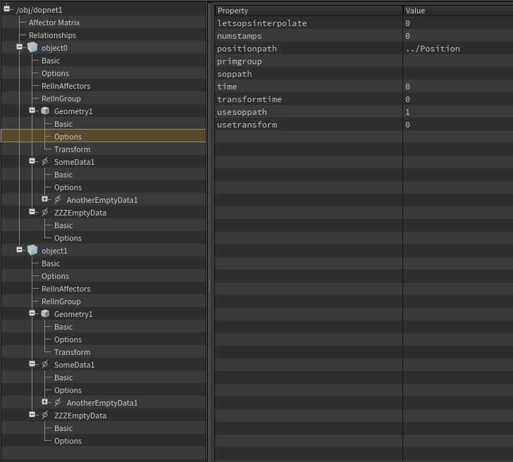

However, we should include the apply data node in the graph, even if it has a bypass flag:
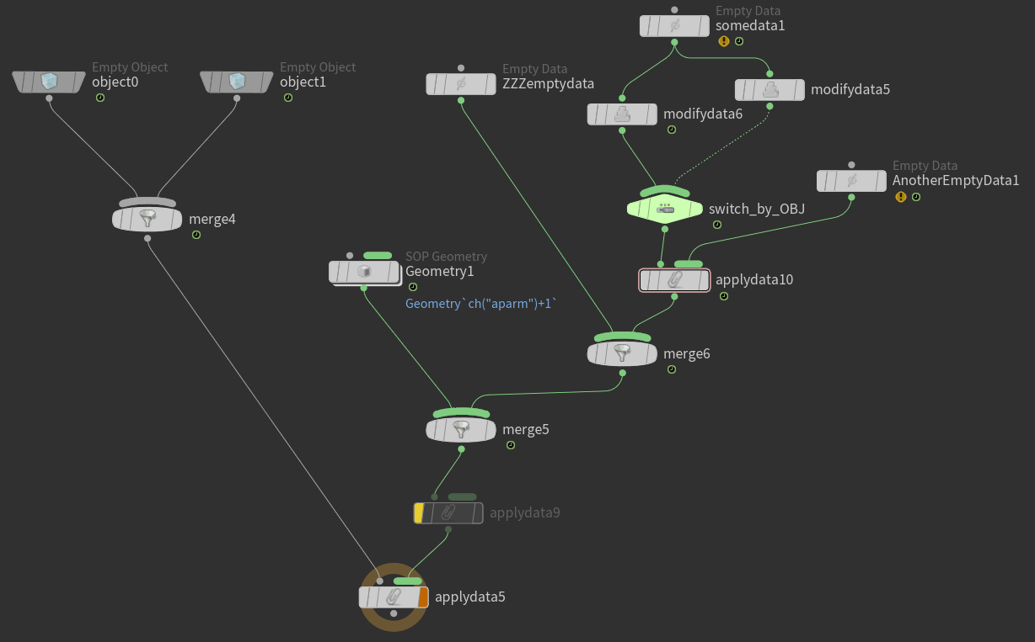
the resulting data structure will change completely:
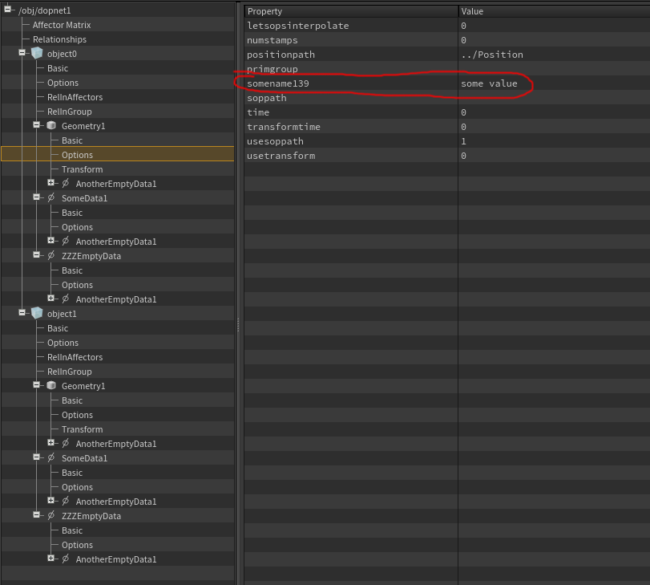
Note that the data with the reference name AnotherEmptyData1 was created on all data, and the modifydata6 node unexpectedly changed the record field on the Geometry1 data (somename139 = "some value")
(example spptidamop@HPaste (OBJ context))
General information about data node execution:
Each data node, in order of depth traversal, will first calculate its basic parameters, such as activation, group and data name, and generally decide whether it needs to work, whether they are suitablecurrent objectto the specified group (if not, the node is simply skipped), if oncurrent datathere is no sub-data with the name calculated by the node, then new data is created and added tocurrent data as sub-data, with a computed reference name.
If a link with the same name already existed oncurrent data, then the data at this link will be transformed into the data type created by this node, instead of creating new data. After this, the remaining parameters from the node will be applied to this data as before (more on the transformation process later). The link to the created/transformed data will be added to the data stream inNormaloperating mode, or inlocal data listcurrent subgraph computation inBrokenmode.

Nodes such as modify data in the data flow will be applied to each data in the input list inNormalmode, or to data inlocal listcurrent subgraph computation inBrokenmode.
merge node - combines data streams (without repetitions) intoNormalmode, and does nothing at all inBroken, where it serves only to define the graph structure. The relationship field on it is also inactive in the data flow, because relationships only make sense for objects.
If an apply data node is encountered along the way, then exactly the same thing will happen as described earlier:current dataat the moment before entering apply data will be remembered and postponed, now each data fromlocal list (if, while going down the graph, we came across the apply data node, entering its first input, we are already obviously inBrokenoperating mode)will be set ascurrent data(since this is not an object, the variables $OBJ $OBJID $OBJNAME etc. will not be changed), and all subgraphs will be calculated for them, from left to right by depth-first search, recursively, according to the same principle that we describe, starting inNormalmode. For each calculation of each subgraph. Upon completion of the node, apply the data storedcurrent data Before applying, data will be restored and graph computation will continue.

Let's look at an example of traversing a node graph:
We haven't yet talked about the Data Sharing parameter, which is present on all data nodes; for now, we assume it is always in its default value.
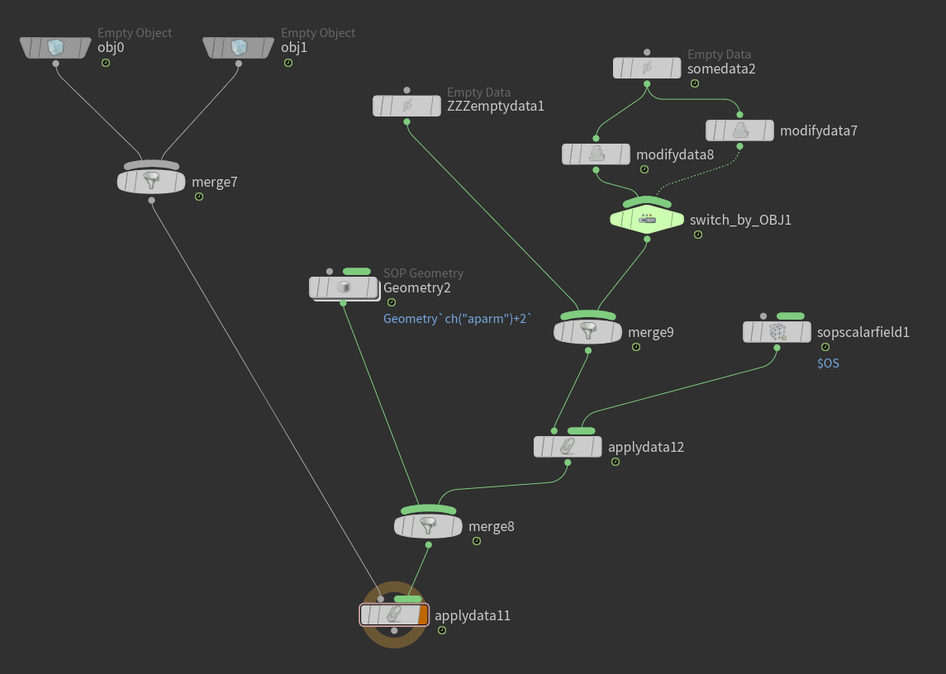
Let's look at the first calculation of this graph (for clarity, the nodes for creating objects and data create objects and links to data with the same names as the nodes themselves)
First, nodes obj0 and obj1 will create new objects and pass references to them, which merge7 will combine into a list of two objects and pass down to applydata11
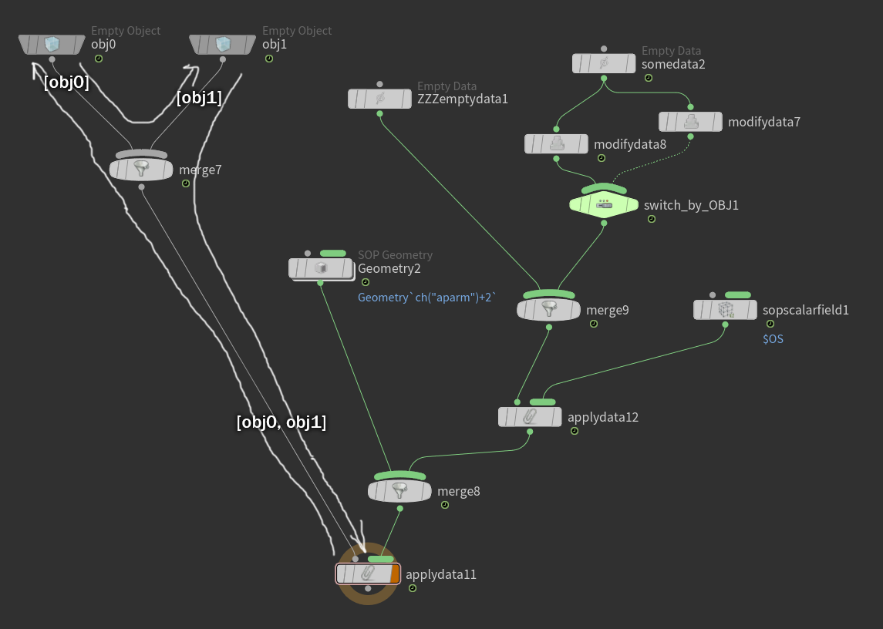
Now, for each of the objects obj0 and obj1, all subgraphs of the non-first input applydata11 (only one in this case) will be calculated. The current data will be initially assigned to the obj0 object, the $OBJ* variables and other object-related variables will be set according to the current object. First, the Geometry2 node will be calculated, creating data of the SIM_SopGeometry type and immediately attaching a reference to it with the name Geometry2 to the current data obj0. The reference to the data will also be passed downstream in the graph (since the graph is calculated inNormalmode)
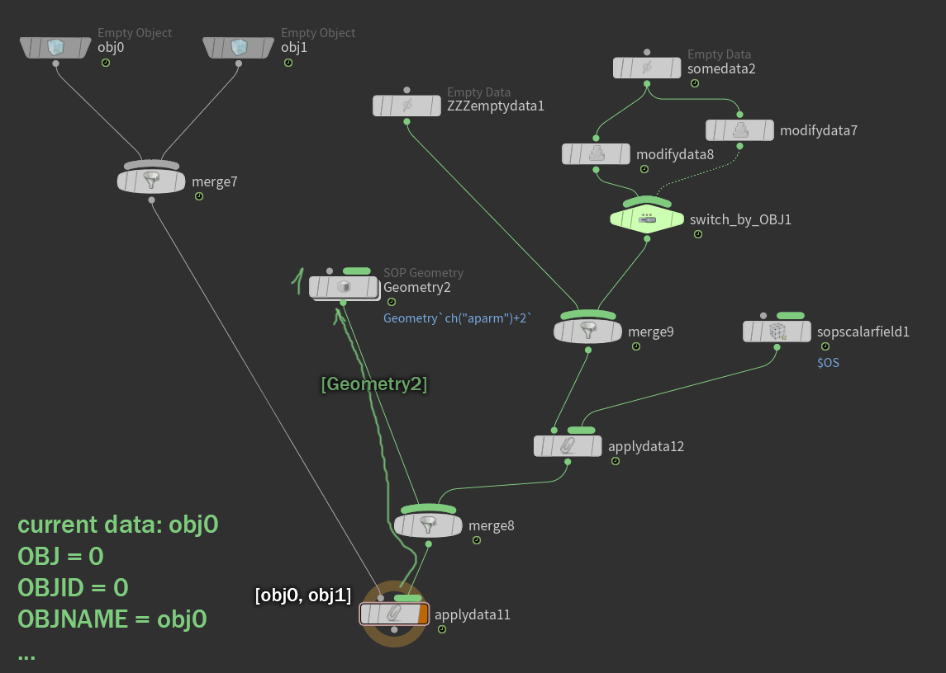
The next traversal will proceed through applydata2 merge9 to ZZZemptydata1.
Note further that the dark-marked subgraph is included in the first input of the apply data node in the data flow, meaning that its computation will take place inBrokenmode, but the order of node evaluation will remain the same. The ZZZemptydata1 node will create data of the SIM_EmptyData type and immediately attach a reference to it to the current data (still the obj0 object). However, the reference to this data will not be passed down the stream due toBrokenregime, it will be added tolocal data listcurrent computation of the broken subgraph)
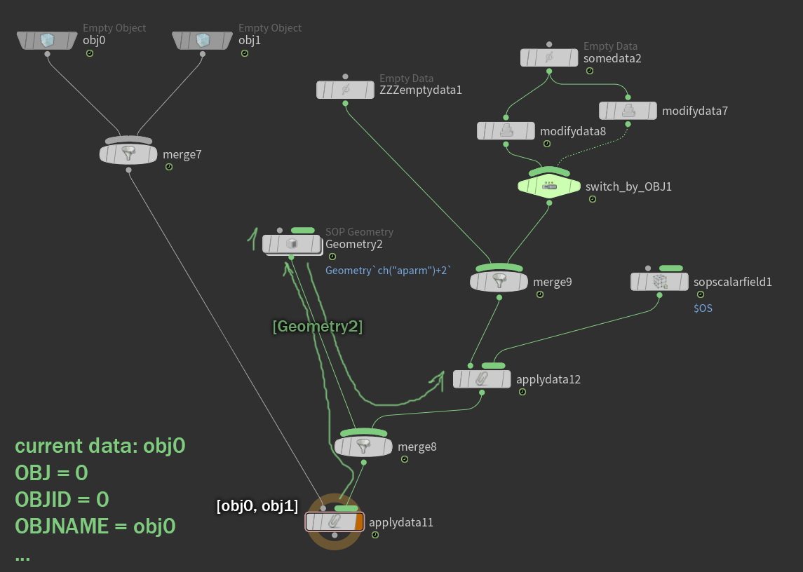
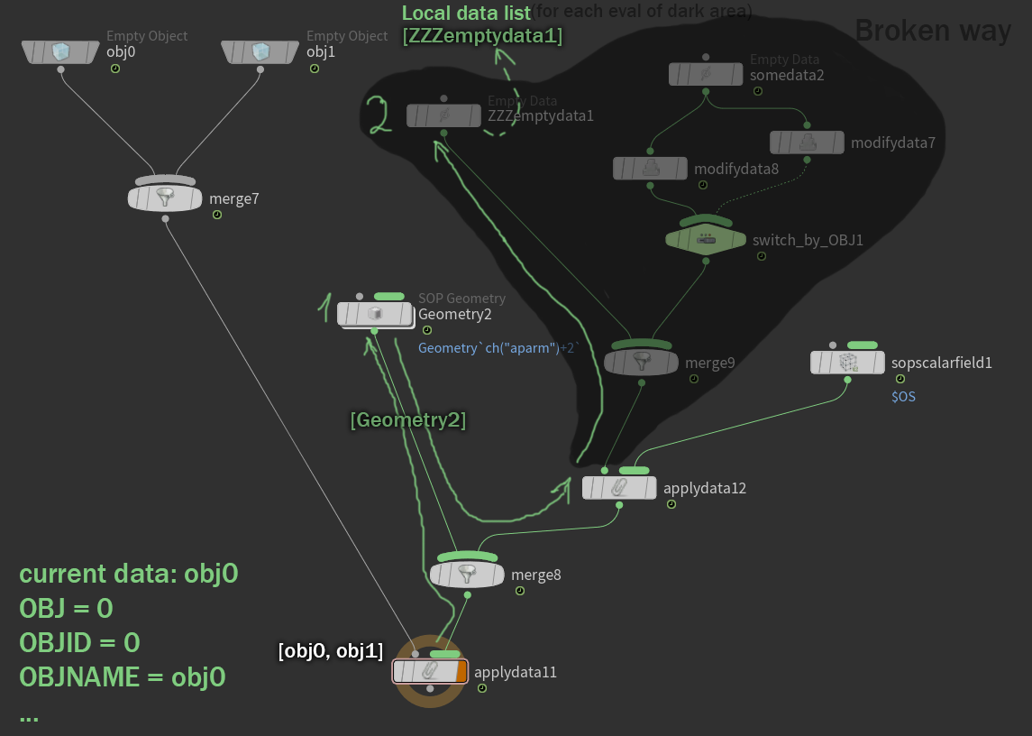
The switch_by_OBJ1 switch has the $OBJ variable in its value, so as soon as it is encountered during the graph traversal (the first encounter for each traversal), the $OBJ value will be evaluated to 0, and this will direct further traversal along the left branch.
Now the node somedata2 will be executed - it will create data of the SIM_EmptyData type again, a link to them under the name somedata2 will be added to the current data (obj0), and inlocal data list
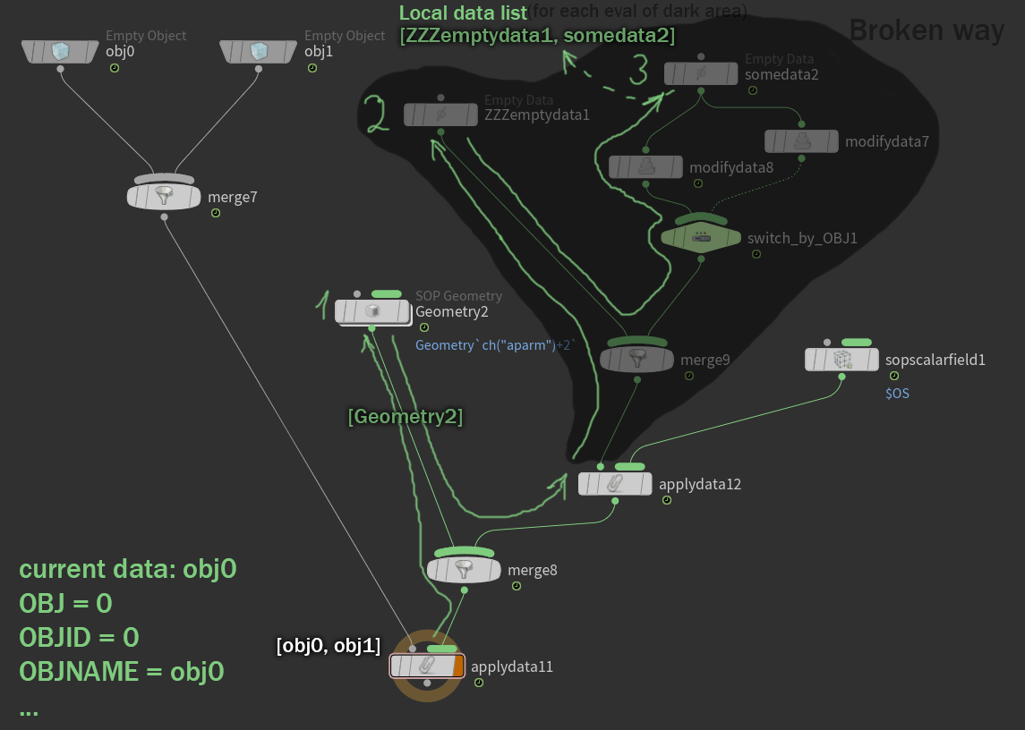
Now it's time to calculate the modifydata8 node. BecauseBrokenoperating mode, the modifydata8 node will operate on the entire local list, both on ZZZemptydata1 and on somedata2, both data will undergo changes.
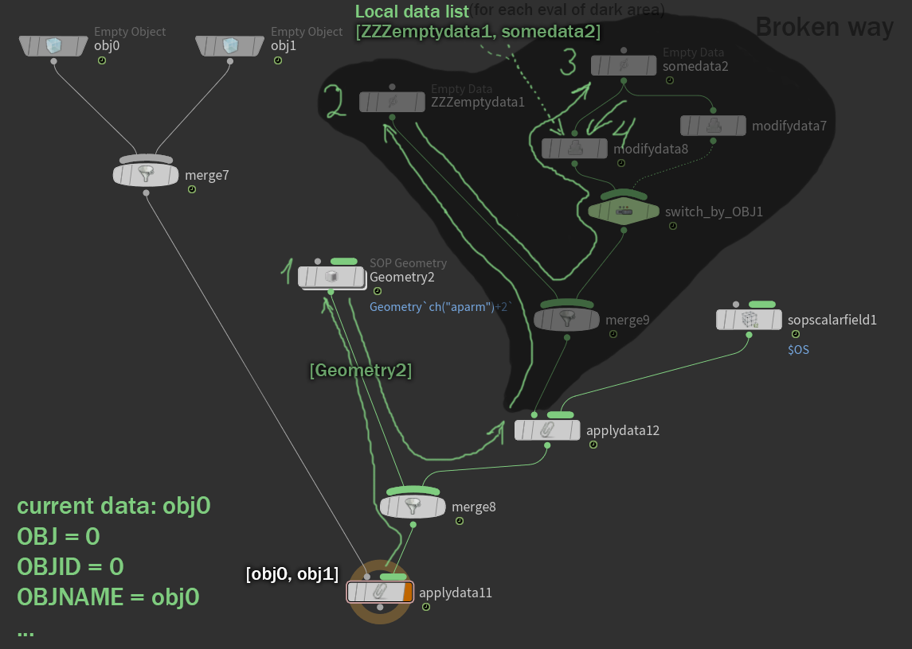
Now local data listwill be fed to the applydata12 node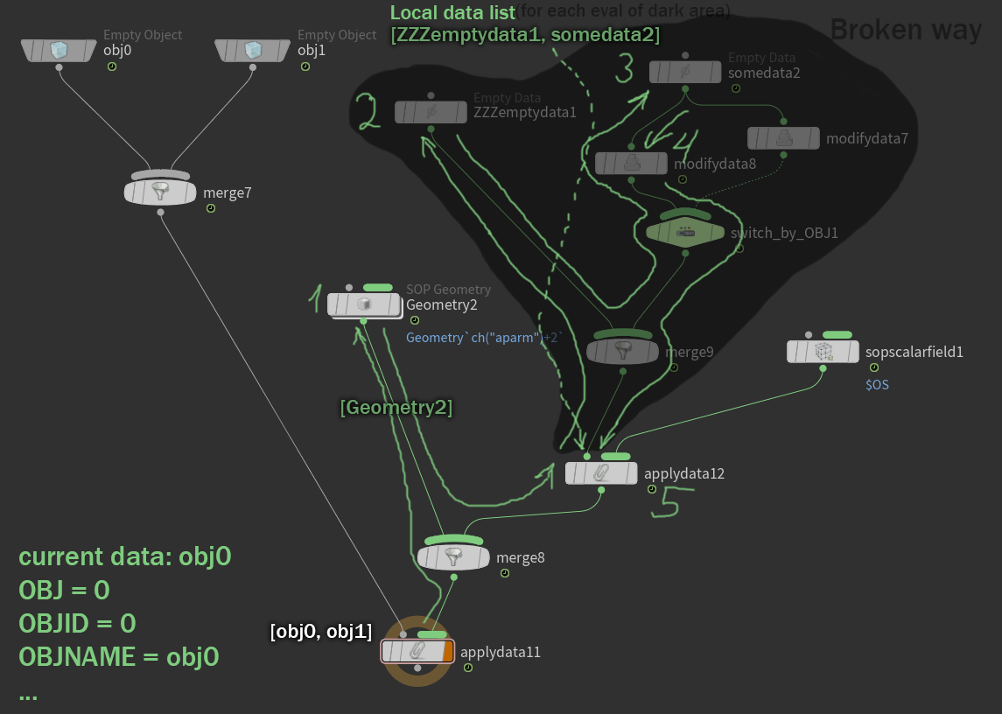
applydata12 for each data from this list will calculate all its subgraphs (the only one in this example) of the first input (inNormalmode). The first data from the list (ZZZemptydata1) will be assigned as the current data. The sopscalarfiled1 node will be calculated, data of the SIM_ScalarField type will be created, and a reference named sopscalarfield1 will be added to the current data (ZZZemptydata1).
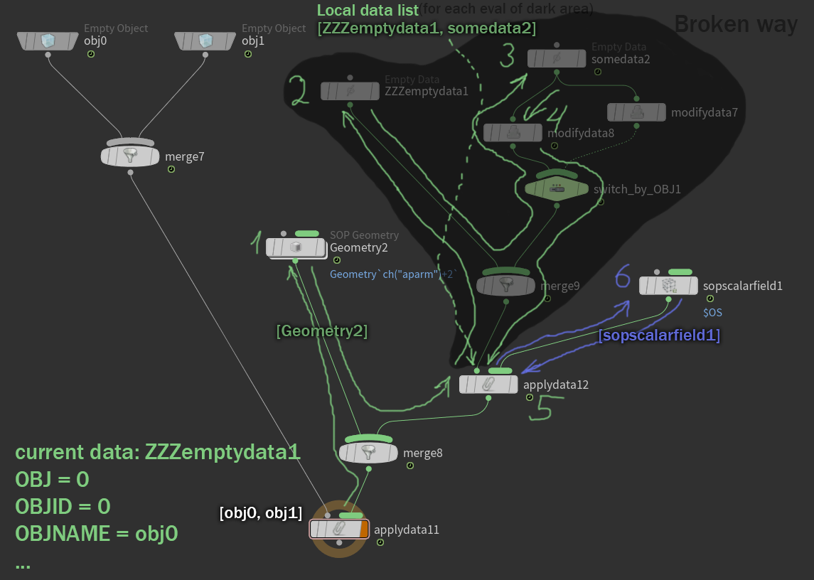
then the current data will become somedata2 on obj0, and the calculation of the node sopscalarfield1 will be repeated
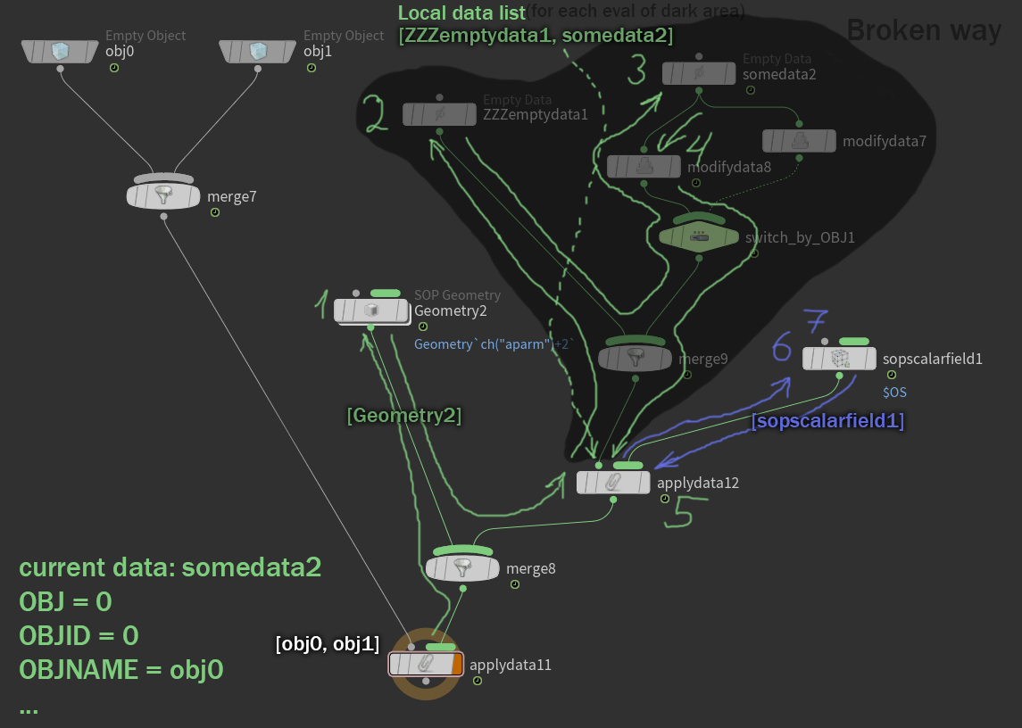
Now local data list Brokensubgraph will be returned by the applydata12 node to the subgraph running inNormalmode, so it will be passed downstream of the graph.
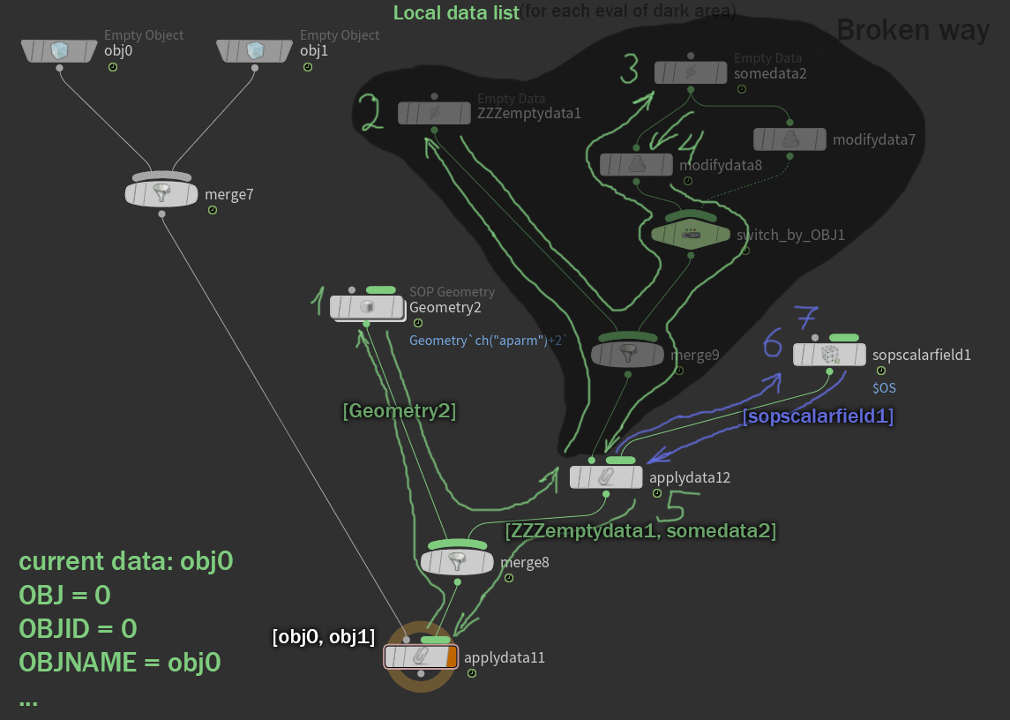
The merge8 node will merge the data lists, which will be passed down and end up at the beginning of the graph. This will complete the calculation of the subgraph of the second input of applydata11 for the object obj0 (remember that the data is already fixed where it needs to be, applydata11 will no longer do anything with it).
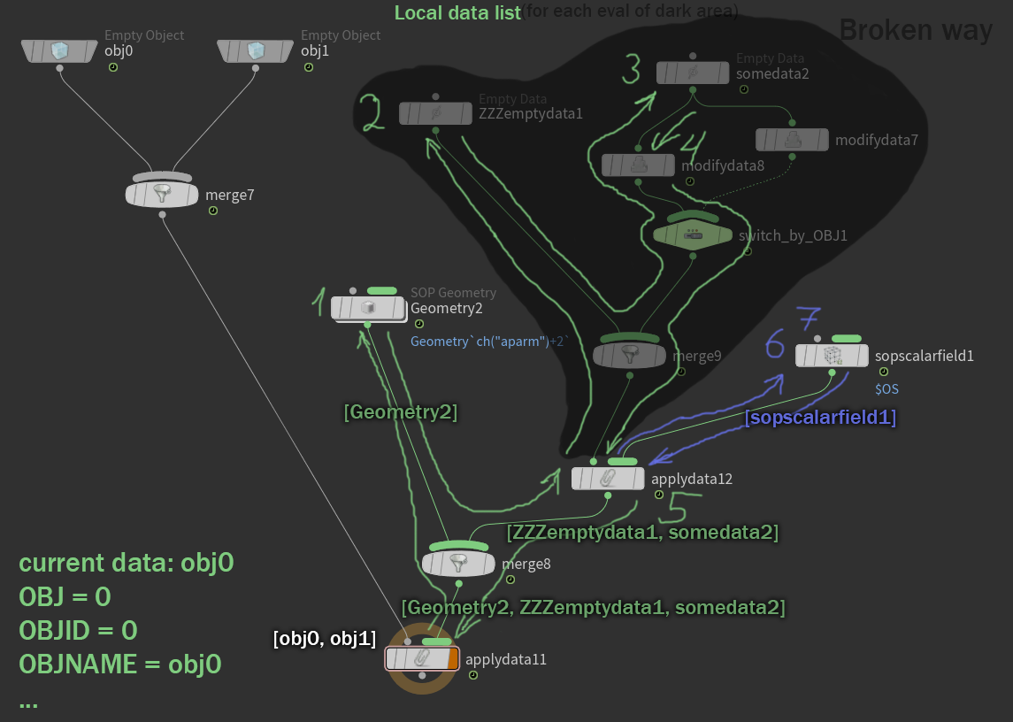

Now the current data will be set to obj1, and the subgraph of the second input, applydata11, will be recalculated for it. Let's quickly run through this execution:
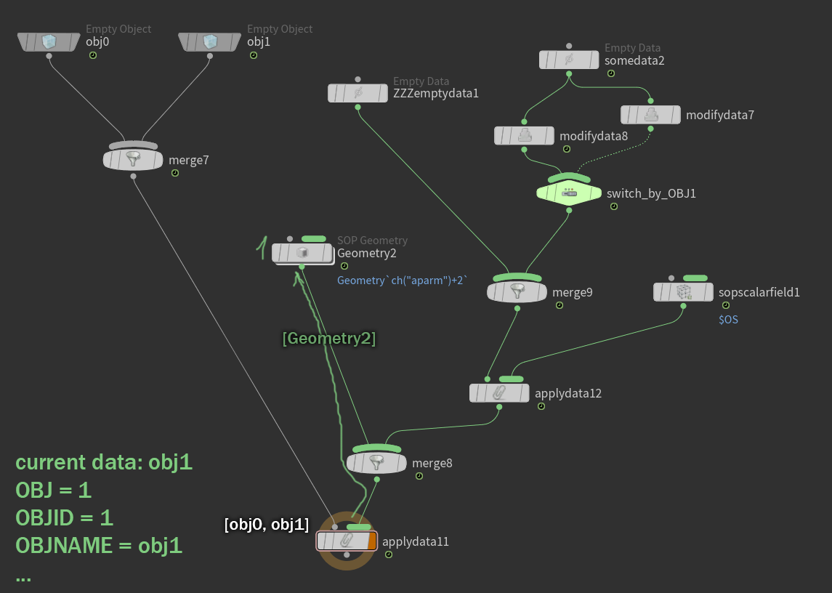
All the description above is also true for executing the subgraph for the object obj1, only the switch switch_by_OBJ1, which has $OBJ as its value, will direct the traversal of the graph along a different branch as soon as it is encountered on the way.
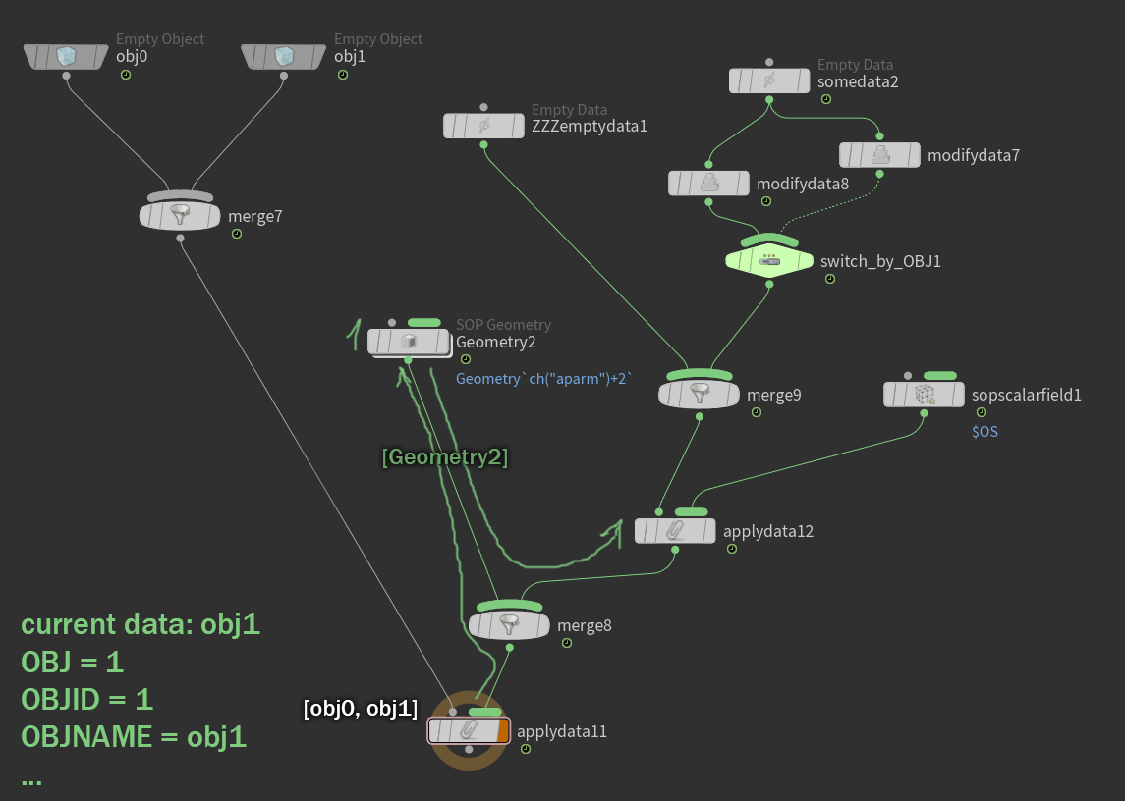
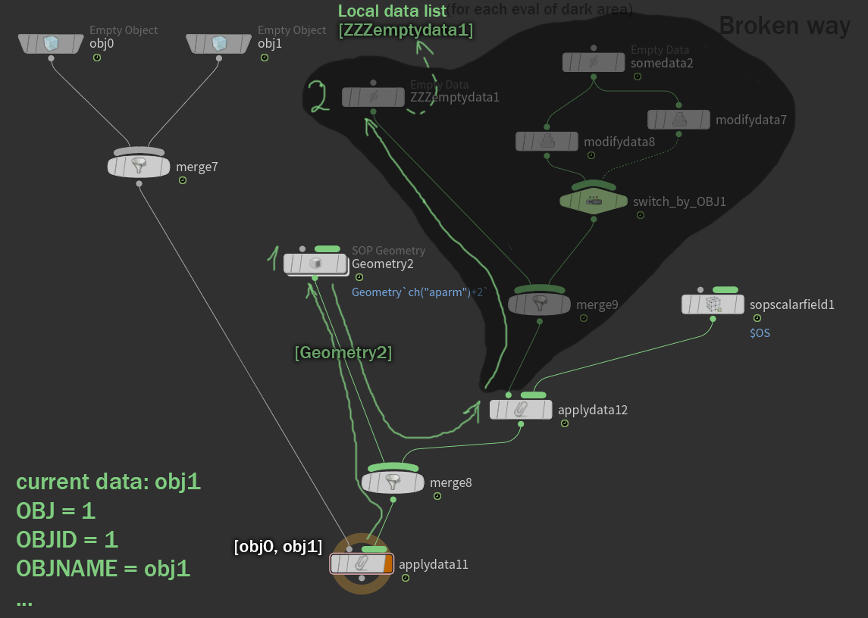
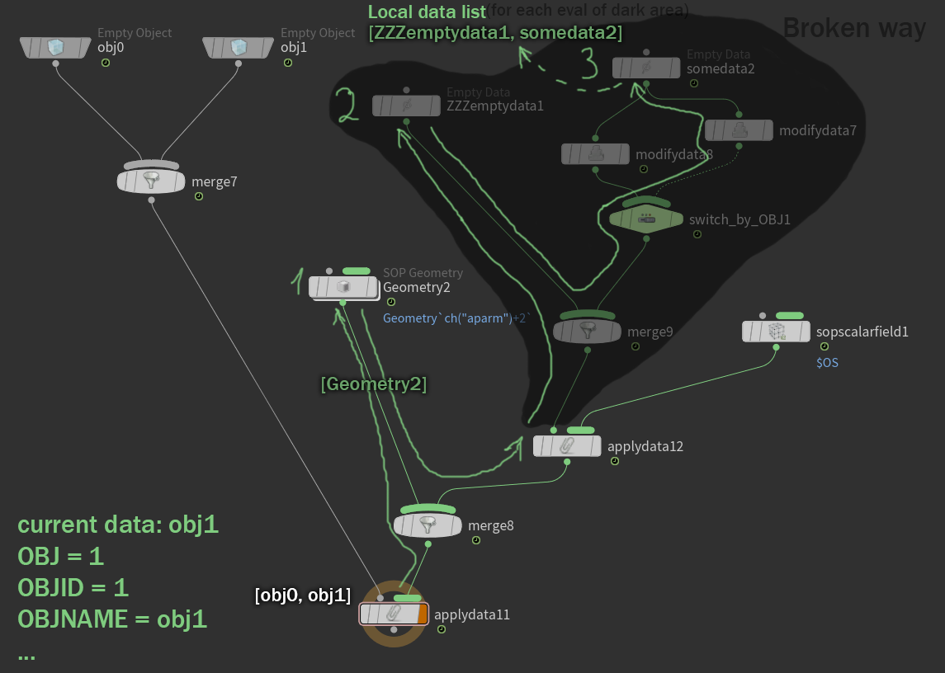
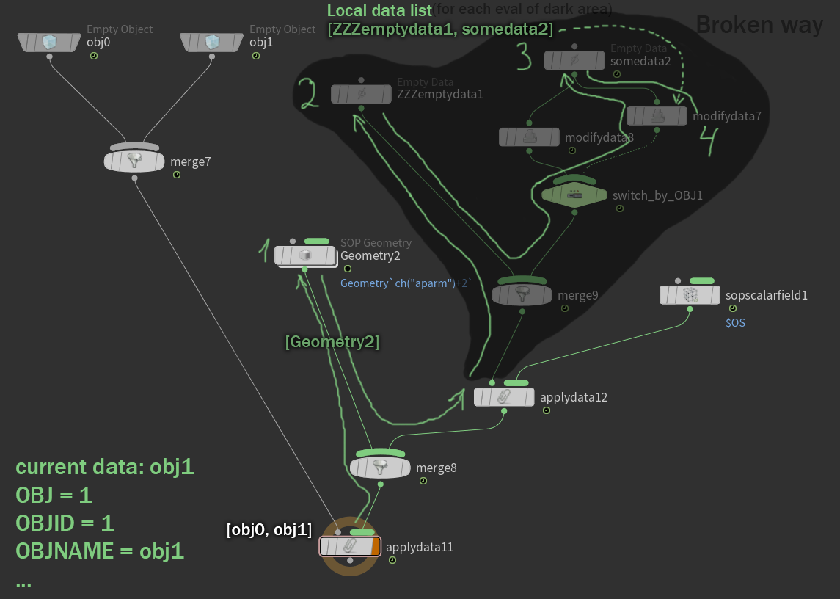
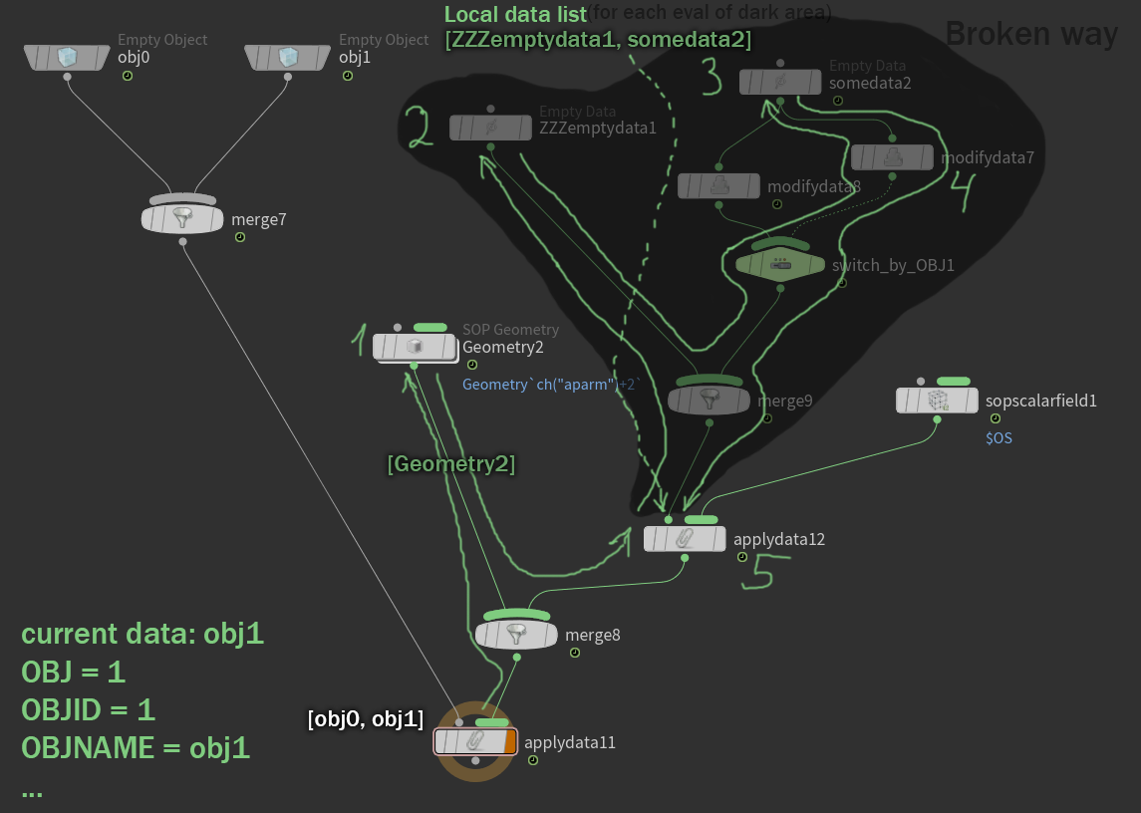
and again for each data inlocal listthe subgraph of the second input in applydata12 will be executed
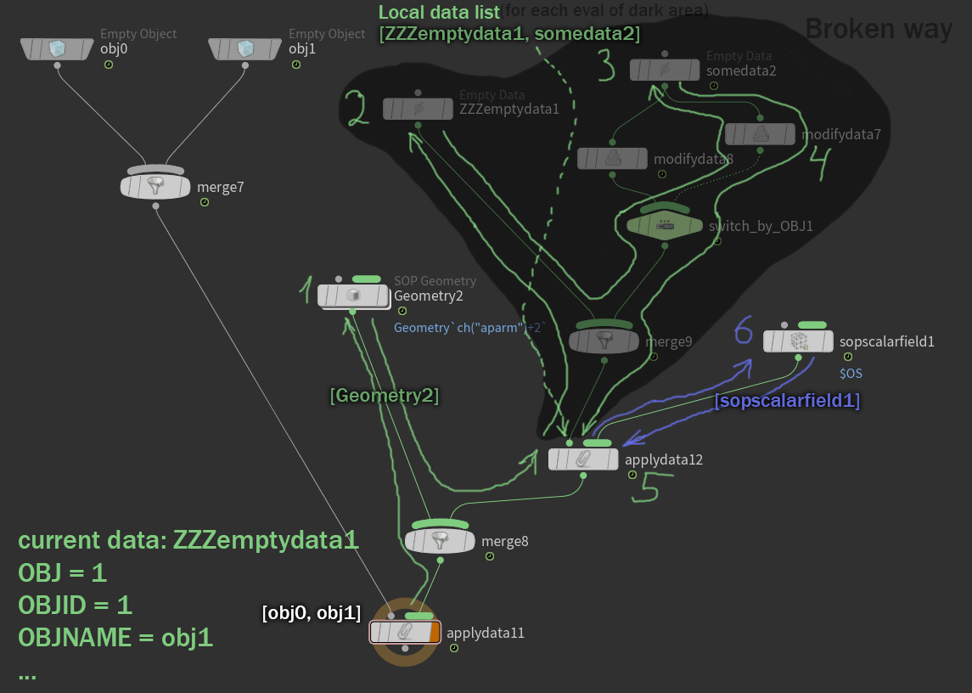
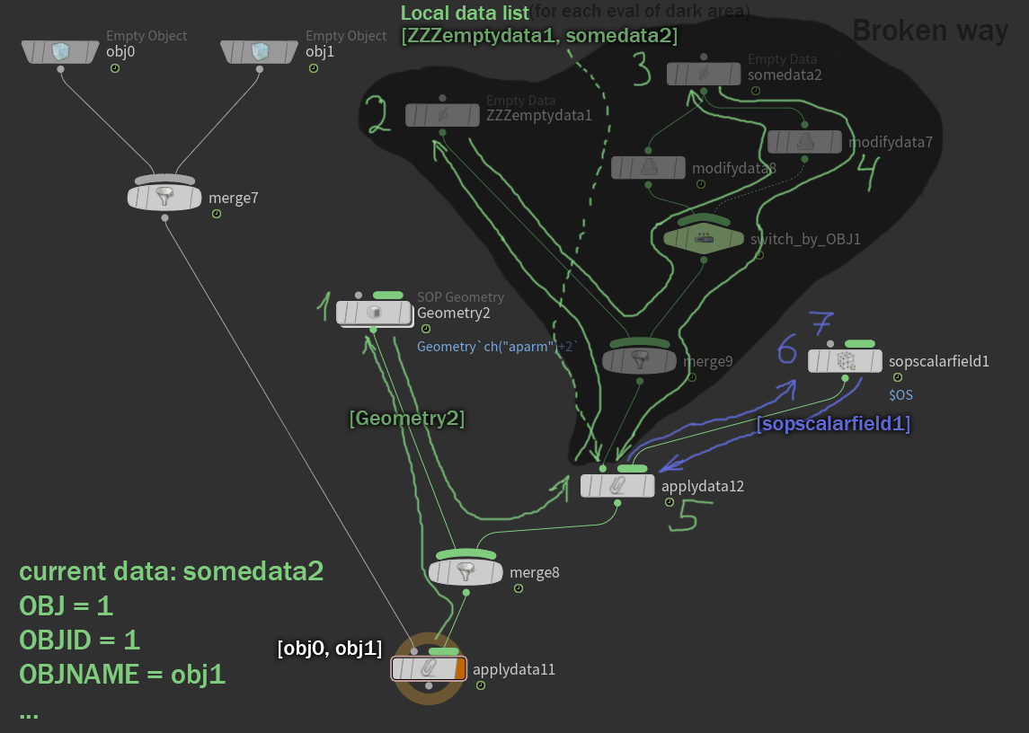
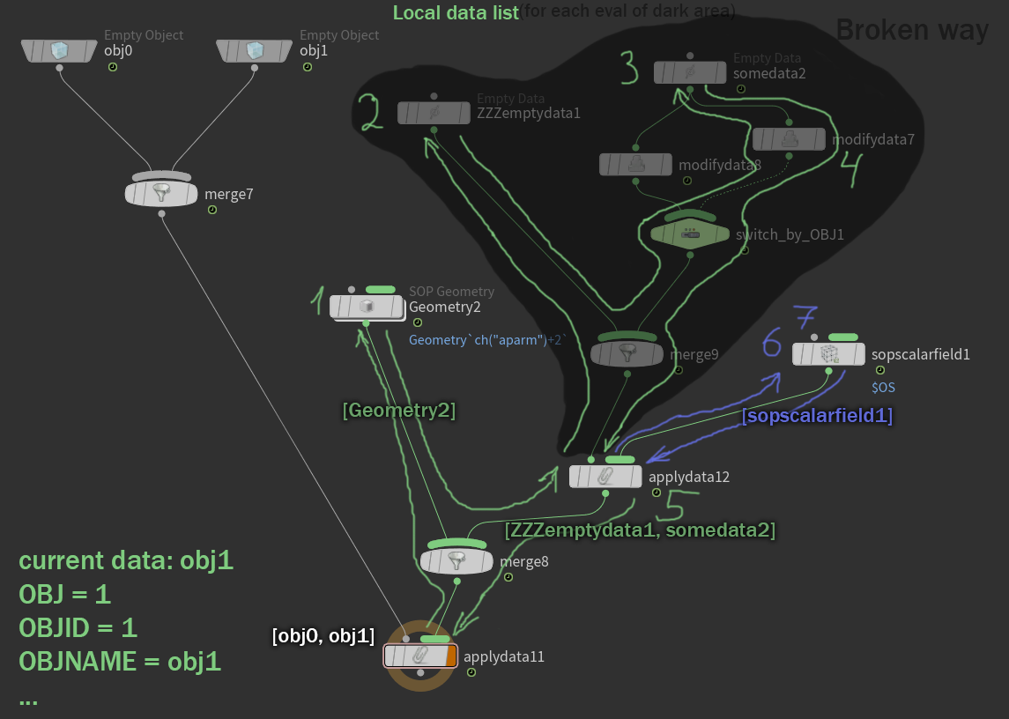
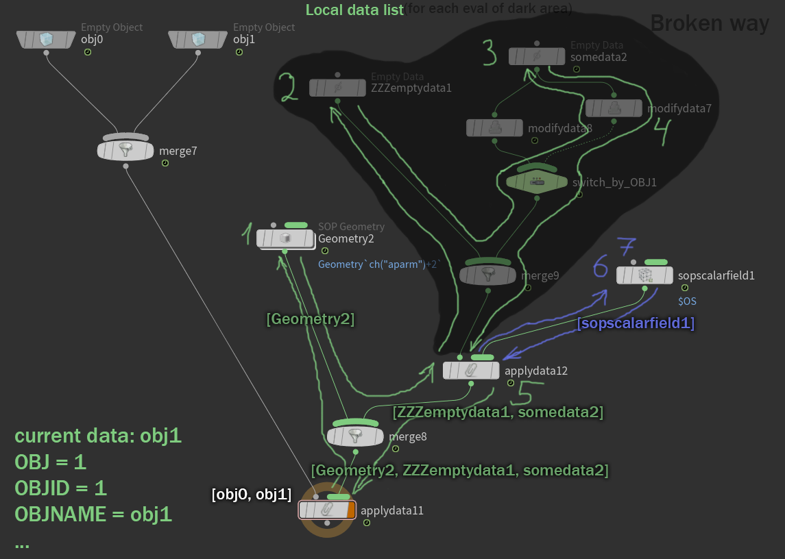
and at this point the execution of the graph will be completed
As a result, the following data structure will be created:
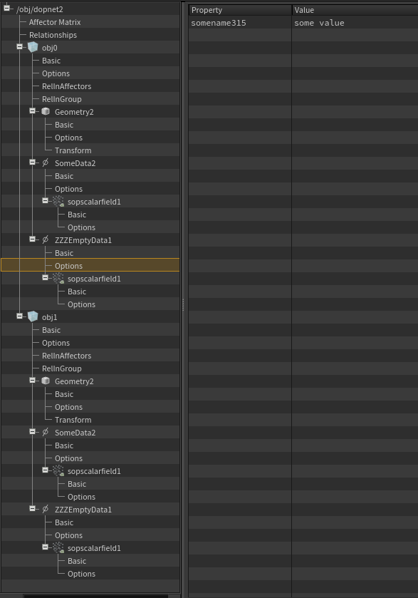
Note that our custom field created by the modifydata8 node was created on both SomeData2 and ZZZEmptyData1
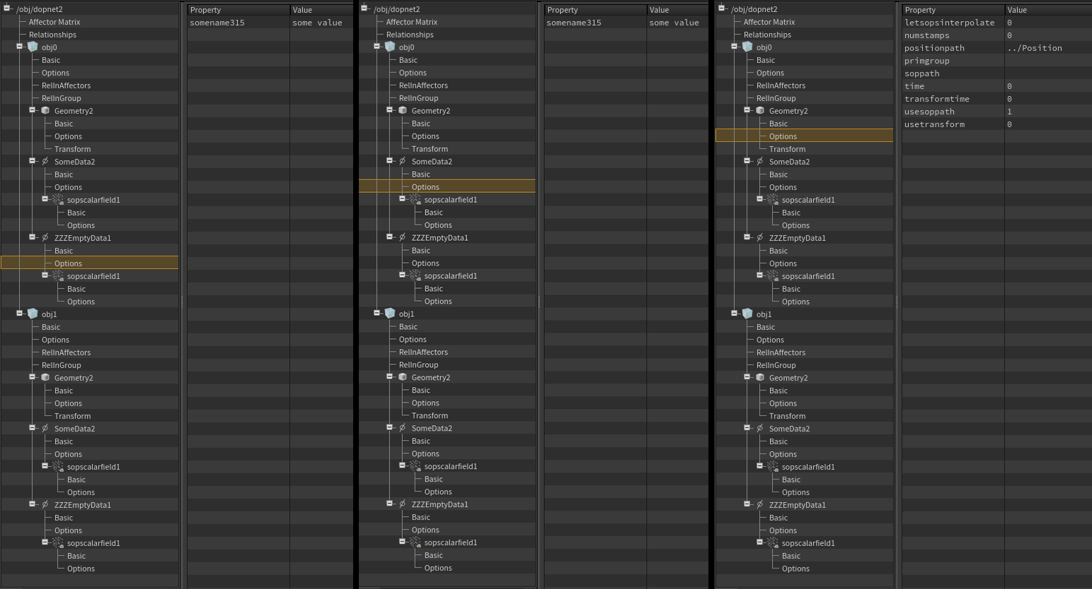
however, it did not work on Geometry2 as expected, since Geometry2 was created inNormalgraph traversal mode, and SomeData2 and ZZZEmptyData1 are inBrokenin single subgraph traversal mode
(scene described example:sppoqituka@HPaste(OBJ context))

The example above described the node graph calculation scheme for the first simulation timestep, when there was no data in the simulation yet. What happens in the next timestep? In other words, in any timestep with any data structure already existing in the simulation?
As described earlier, traversal and execution of nodes will occur in exactly the same way, it will only be necessary to add that nodes obj0 and obj1 will calculate their activation and number of objects parameters and decide whether they will create new objects or not, and the lists of objects they produce will be added to the objects that already exist in the simulation, whose creator field contains the path to any of these nodes, respectively.
Data application will follow the same pattern, but instead of creating data of a specific type, if any data with a reference with the given name already exists in the current data, the existing data will be transformed to the requested data type. If the data already has a specified type, as in the vast majority of cases when data of one type is simply updated from one simulation timestep to the next, a reference to it is simply returned, and no processing occurs. How data can be transformed from one type to another is determined by the programmer at the data type creation stage. The most Houdini can do automatically is create new data from scratch and copy references to it from subdata and records from the transformed data. Of course, Houdini itself, without the programmer's help, cannot know anything about the internal structure of the data or how to transform it into another. So, in our case, on the second simulation frame, all data nodes, instead of creating new data, will simply return references to the existing ones they created earlier; nothing new will be created.

DOP groups.Groups in the DOP context are intuitively similar to groups in SOP. Unlike SOP, DOP groups can only contain DOP objects and nothing else. Many DOP nodes have a Group field containing the group pattern understood by that node. This pattern applies not only to the names of additional groups to which an object belongs, but also to the names of objects and their objid. If an object from the processed list (in the object stream) or the current object (in the data stream) does not match the pattern specified in the node's group parameter, the node for this object is not executed. DOP groups are implemented through group relationships without affectors, meaning they do not affect the determination of the solver evaluation order.

Data Sharing parameter
We already know how data can have multiple, differently named references to different data; in this case, the data is called shared. The default interface of all nodes that produce and attach data includes one parameter, the purpose of which is to provide the user with at least some control over how to create shared data on different objects or data. This parameter Data Sharing.
Despite the likely noble idea, the final implementation introduces even more confusion into the already relatively broken calculation of additional nodes.

Do not share data
Everything described above is true for the default value of data sharing - "Do not share data".
Each time a data node is executed, it is executed separately, regardless of its previous executions in the given timestep or in the past.
Using a simple setup as an example, we can see that the data is created differently
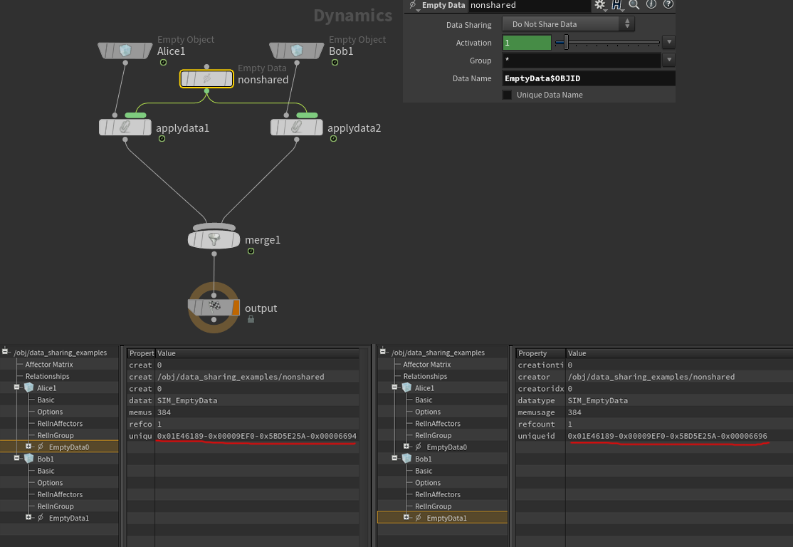
(computation order: Alice1 -> nonshared -> Bob1 -> nonshared -> merge1 -> output)
Let's complicate the setup a bit: notice in the first timestep that the data is still completely different, modifydata1 only affects Alice1a's data, another_modifydata1 doesn't work yet, because the data is created only after its execution during the depth traversal of the graph)
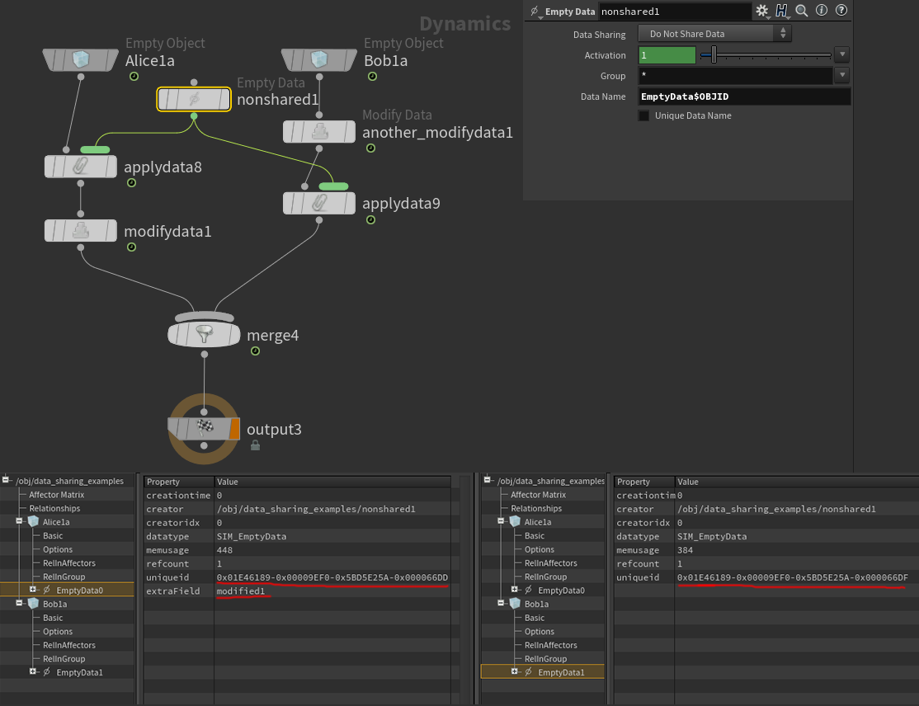
(evaluation order: Alice1a -> nonshared1 -> modifydata1 -> Bob1 -> another_modifydata1 -> nonshared -> merge1 -> output)
Here's the picture on the second time step:
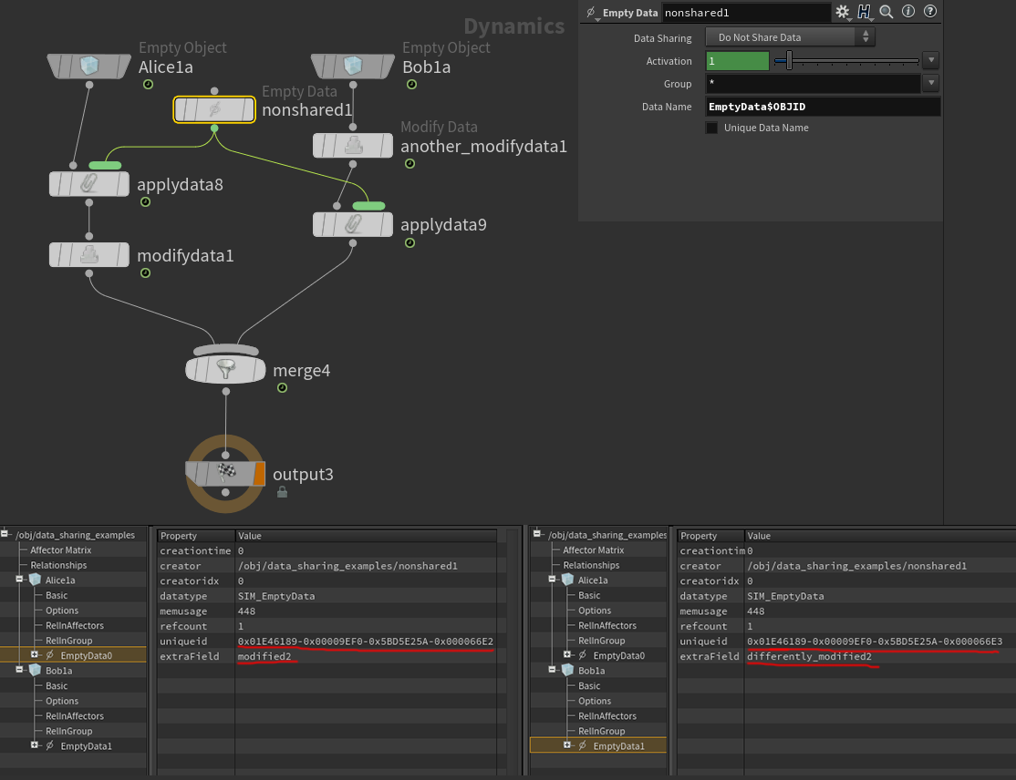
(the calculation procedure is the same)
Note that the data on Alice1a and Bob1a are processed completely independently, according to the logic described above.
(example:sppsorenuc@HPaste(OBJ context))

Other values ​​for the Data Sharing parameter change the logic of how the node creates data:

Share Data In One Timestep
In this mode, during each timestep's first processing, this node will remember the object number and the name of the object's reference to the processed data (not the actual data reference) (with the names of references to its parent data, if the reference is at the object's root, or to other subdata, e.g., object: smokeobject1, data reference name: density/Visualization). And during all subsequent executions in the current timestep, it will return the remembered data instead of any standard processing. This means that this data could be deleted, recreated by another node, or modified in any way, but the aforementioned node will still return it, instead of creating or processing the data in the traditional way, because the search is performed by the object number and reference name. (This is true for castable data types, but the returned type will be an uncast type. This means the GeometryCopy node could return SIM_SopGeometry data, which could lead to even more confusion than described above. For irreducible data types, the node will forget the remembered object number and reference name and will operate as if for the first time in this timestep—that is, it will re-remember the object number and reference name of the currently processed object's data.)
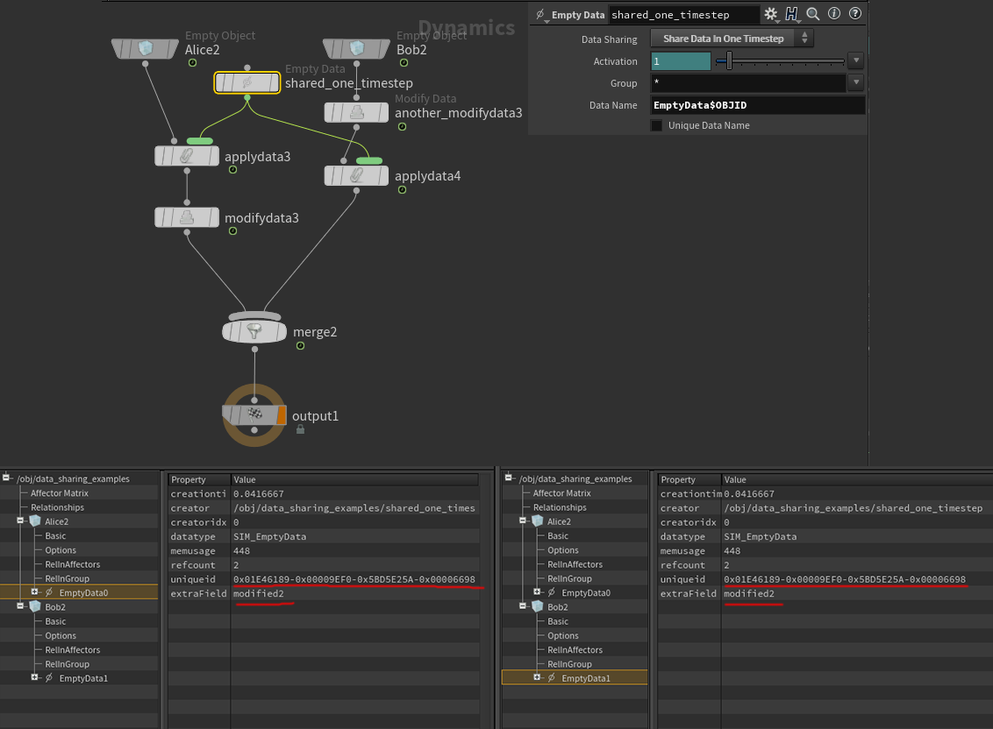
(evaluation order: Alice2 -> shared_one_timestep -> modifydata3 -> Bob2 -> another_modifydata3 -> shared_one_timestep -> applydata4 -> merge2 -> output1)
In this example, it is clear that the shared_one_timestep node first creates data on the Alice2 object, remembering the name of the reference to the created data and the object number, so when shared_one_timestep is processed for the current data of Bob2, it does not look for data on Bob2, it takes data from Alice2 by the remembered name, so even if the original data created by shared_one_timestep on Alice2 was copied and replaced, it is the new data attached to Alice2 that will be taken by name, and if their type matches or is cast to SIM_EmptyData (in this case, and in most cases, the types will match exactly) - they are attached to the current data of Bob2 with a reference with a new name calculated for Bob2 (note in the screenshot that the names of the references to the same data are different for the objects).
And every frame, despite the fact that the node another_modifydata3 will copy and modify the data EmptyData1, the subsequent triggering of the node shared_one_timestep for Bob2 will overwrite this reference to the one pointing to the data EmptyData0 from Alice2
(example)sppagojege@HPaste(OBJ context))

Share Data Across All Time
This mode is similar to the previous one. All the logic of the previous mode is correct, with the caveat that instead of localizing to a single timestep, the behavior extends to the entire simulation, meaning the remembered object number and reference name are not forgotten when moving from timestep to timestep. There is one silly bug I noticed, which I'll describe after the example to avoid confusion.
Just as in the case of Share Data In One Timestep, if no data is found by the remembered object number and data link name, or if data is found that cannot be converted to the data type produced by this node, the "memory" of the data creation node will be reset, the object number and link name will be forgotten, and the node will be executed as if for the first time.
Let's look at a slightly more complex example to demonstrate the peculiarity of this Data Sharing mode. The meaning is that the applydata5 branch is triggered only during the Alice3 object creation timestep, after which the only_at_creation_frame switch always returns a zero path. Alice3 and Bob3 objects are created simultaneously, while Carol3 is created later, some time later.
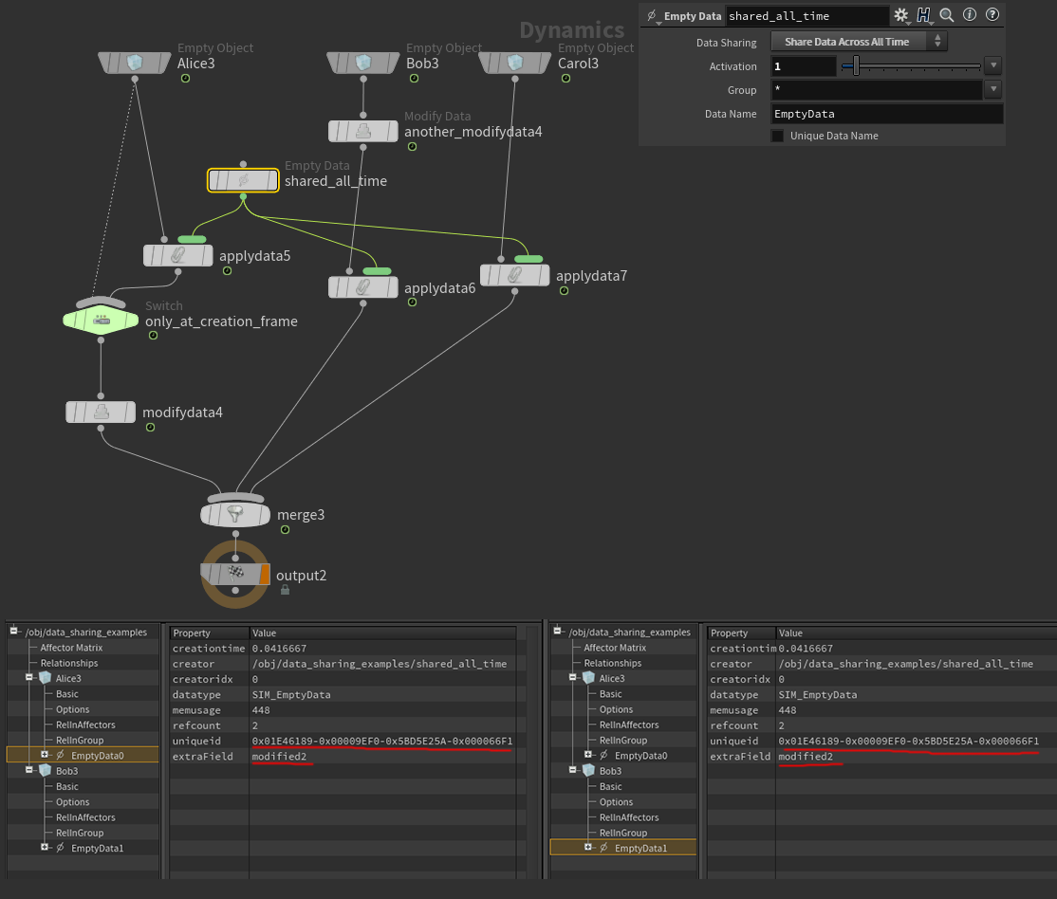
(execution order: Alice3 -> shared_all_time -> modifydata4 -> Bob3 -> another_modifydata4 -> shared_all_time -> Carol3 -> shared_all_time -> merge3 -> output2)
In the first timestep, we see a picture identical to the previous example. The share_all_time node remembered the Alice3 object number and the EmptyData0 data reference name, and attaches them to the Bob3 object with the EmptyData1 reference name. Now let's look at one of the following timesteps, but before the Carol3 object is created.
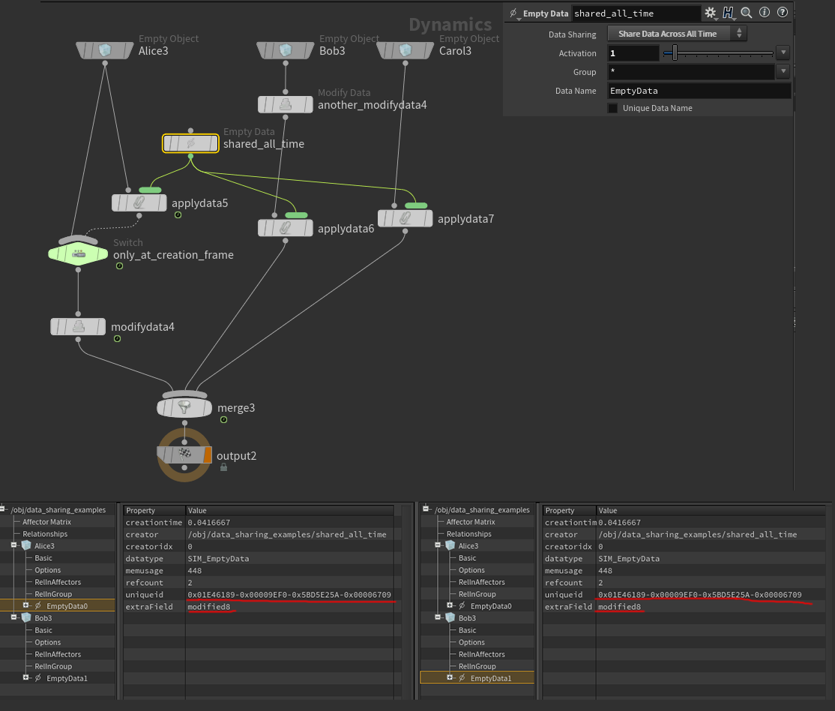
(execution order: Alice3 -> modifydata4 -> Bob3 -> another_modifydata4 -> shared_all_time -> Carol3 -> shared_all_time -> merge3 -> output2)
Now applydata5 will never be evaluated, modifydata4 on Alice3 will change the EmptyData0 data created in the first timestep on Alice3, but the share_all_time node will never be processed with the Alice3 object again due to the switch. However, we see that despite the action of the another_modifydata4 node, which copies the EmptyData1 data to Bob3 and changes extraField to differently_modified$F, the subsequent execution of the share_all_time node for the Bob3 object will overwrite the reference pointing to the data found by name on the stored object by number during the first execution in the first timestep on the Alice3 object. Note that it is important that share_all_time stores not a reference to the data, but the object number and the data name. Therefore, it returns not a reference to the data stored in the first timestep, but the data by name on the stored object by number at the time of the next evaluation.
Now let's look at the time step of creating the Carol3 object
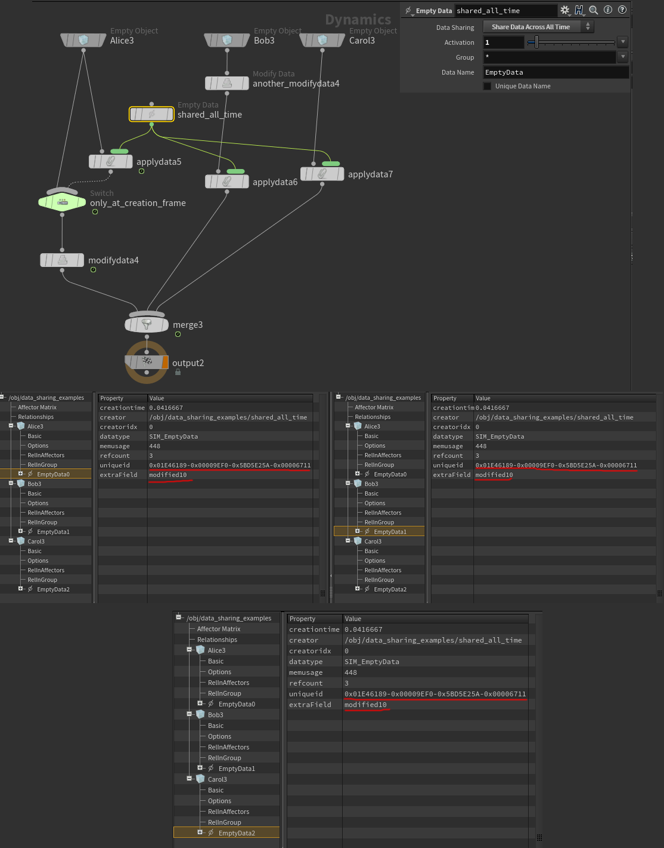
(execution order: Alice3 -> modifydata4 -> Bob3 -> another_modifydata4 -> shared_all_time -> Carol3 -> shared_all_time -> merge3 -> output2)
At this time step, everything happens the same way as at the previous one, only in addition, a new object Carol3 is created, and a link to the same data is attached to it, obtained by the object number and the data name from Alice3, just like for Bob3, but with the personal link name EmptyData3
(example)sppnocejox@HPaste(OBJ context))

Let's return to the bug I mentioned. If you open the Share Data Across All Time example, you'll see that the Alice3 and Bob3 objects are created not in the first simulation timestep, but in the second. This is due to a discovered bug that resets all remembered references for nodes in Share Data Across All Time mode only after the first timestep. In other words, in the first simulation timestep, nodes in Share Data Across All Time mode actually operate in Share Data In One Timestep mode. Starting from the second timestep, everything works correctly, according to the described logic. Perhaps there's some hidden meaning to this, but it looks more like a bug, as there's little logic behind this behavior.

Solvers and the Solver Per Object checkbox
You may notice that the nodes of these solvers typically don't have a Data Sharing parameter, but they do have a Solver Per Object checkbox. Since any call to a solver function is by definition considered a change to the solver data, and solver functions are called very frequently (during the solving phase), the Share Data Across All Time mode isn't very practical for solvers. Therefore, the user is given a choice between Share Data In One Timestep—equivalent to unchecking the Solver Per Object checkbox—and Do Not Share Data—equivalent to checking the Solver Per Object checkbox.

Solving stage
The solving stage is much more familiar to many than the node graph computation stage. It occurs without reference to the node graph, but purely on simulated data.

Solving objects
After passing the node stage and all the data changes associated with it, Houdini takes all the relationships associated with the objects of the current timestep and, analyzing which objects influence which, selects the calculation order that best satisfies all the relationships, building a queue of objects; the elements of this queue can be either individual objects or groups of objects connected by mutual relationships.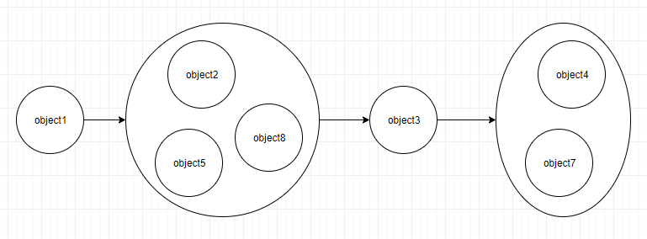
For example, in the classic case of a static and smoke object entering a merge node one after the other, with collide relation and in the "objects on the left affect objects on the right" mode, the order of solving objects is obvious.
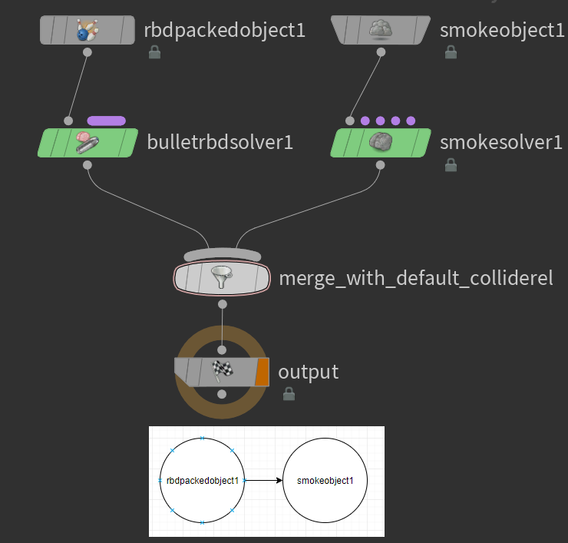
In the case of mutual influence of objects, Houdini organizes the solving queue as follows. (The merge_with_default_colliderel node is the default merge node, creating a collided relationship where left objects influence right ones; the merge without_rel node does not create any relationships.)

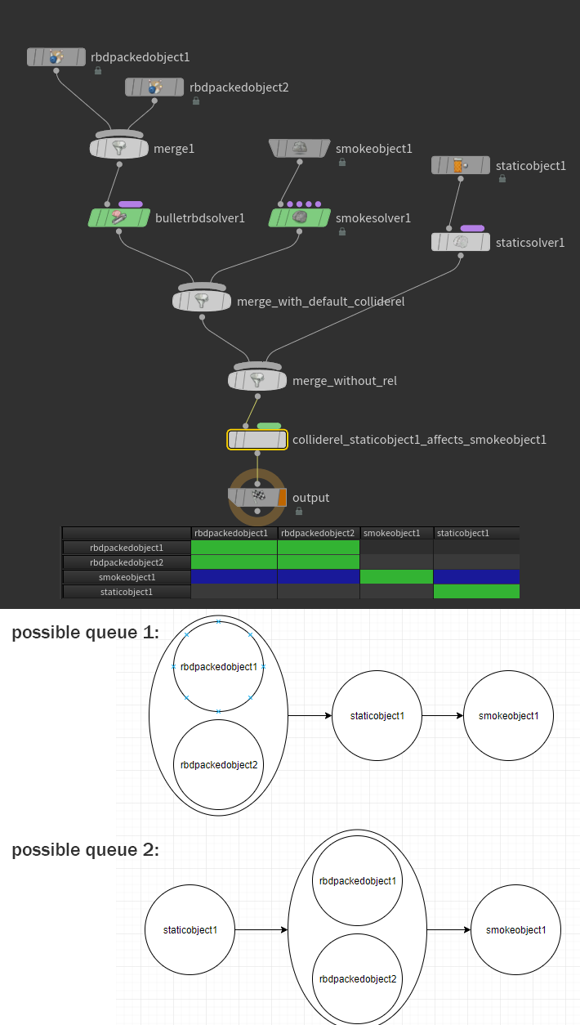Note that since staticobject1 influences smokeobject1 and nothing else, it can appear in the object queue at different locations. However, Houdini will deterministically choose one of these options. Different queues (at different timesteps, for example) cannot appear for the same simulation structure.
(example:sppogijeh@HPaste(OBJ context))

Feedback magnifiers
If all objects in a mutual interaction group share a reference named Solver to the same data (we'll say they have the same solver, or reference the same solver), that solver's functionality will be run once with the passed list of all objects in the mutual interaction group. If, however, a mutual interaction group contains objects with different solvers (note that we're talking about different data, not different solver types—that is, objects can have the same solver type, such as a bullet, but these solvers can represent different data in memory), the objects in the group will be serialized, and their solvers will be run sequentially, potentially multiple times, forming feedback loops.
So, after the node graph calculation stage, we have a data structure for the subdata in the current timestep. The order in which subdata are attached to the data is strictly defined, and the data knows it. However, when viewed through a geometry spreadsheet, the subdata may appear in a different order, often simply sorted alphabetically. If you change the sorting method to "sort none" in the context menu for the parent data, the data will be displayed in the order in which they were attached.
Once the queue is created, solving objects occurs using a much simpler and more stable method than computing the node graph; it can be described literally as follows:
- if the evaluation queue is empty, end the stage
- take the next element from the queue
  - If the element is an object, data with the name Solver of a type derived from SIM_Solver is searched for on it and run for the current object
  - If the element is a group of objects interacting with each other, the objects in this group will be divided into subgroups that share a reference to the same solver data. The feedback cycle counter will be reset.All data with the link name Feedback will be deleted from all objects in the group..
    - For each subgroup, a common solver will be launched in some deterministic order, with a list of all objects in the subgroup passed to it.
    - If the feedback cycle counter has reached the maximum allowed value set on the DOP node, this item is skipped.
Otherwise, a check of triggers for the callback mechanism will be performed:
If data of the SIM_Impacts type with the link name Feedback is detected on one of the objects of the current mutual impact group, and during the current feedback loop (points i and ii) if on the same object either there was no such data, or the number of impacts was strictly less than now, then the feedback trigger is considered to have been triggered.
When the feedback trigger is triggeredthe simulation will bereturned to the state before i)with the Feedback data saved, the feedback cycle counter will be incremented and we are back to i)
- return to 1)
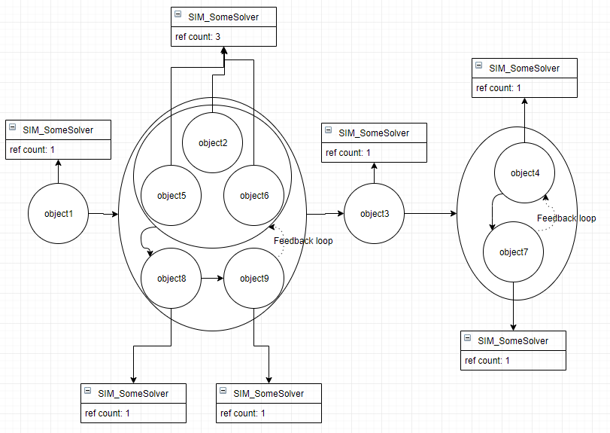

(example:sppawimeka@HPaste(OBJ context))
There may be other feedback loop triggers out there, but unfortunately I couldn't find any documentation on them (even less than on other undocumented mechanisms), so I'll have to make do with some experimental findings.
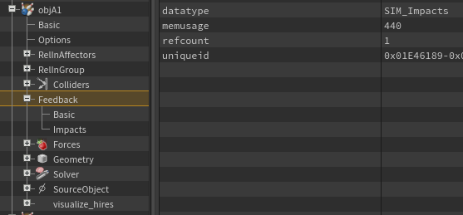

A few words about commonly encountered microsolvers
In Houdini, microsolvers are solvers whose functionality is focused on a specific subproblem, so their use as a solver for an object makes no sense on its own. Microsolvers are designed to be assembled into hierarchical trees that, when combined, solve a single, larger problem.
We know that at the solving stage, Houdini searches for a single data object named Solver and runs its functionality, so there are a number of auxiliary solvers whose purpose is to run their sub-data solvers under certain conditions.

Multiple Solver
A solver container, its functionality consists solely of running the functionality of its solver-type subdata sequentially in the order they are attached. Using this solver, one can attach a series of sequentially launched solvers to an object.

Switch Solver
A solver that launches one of its sub-solvers based on the value of its own field, or a field on other data, allows you to customize solver behavior and launch different sub-solvers based on the results of previous micro-solvers or on the object being calculated. If a switch solver is given a list of objects to calculate, it will check the conditions for each of them, group the objects by the selected conditions, and launch the corresponding sub-solvers with the filtered lists of objects.

Enable Solver
Very similar to a switch solver, it allows you to run or not run the solvers attached to it depending on a condition evaluated during solving. Similar to a switch solver, if an enable solver is given a list of objects to evaluate, it will filter out those for which its condition is met and run its sub-solvers sequentially on this filtered list of objects.

Blend Solver
The blend solver runs the solvers attached to it and interpolates the specified data from the results of the attached solvers. Interpolation weights are specified by the special SIM_BlendFactor data, one factor for each attached solver. More details are available in the help file, but I don't think this solver is particularly common or used, so I don't see any point in dwelling on it further.

Static Solver
A solver that does nothing. Useful when you need the formal presence of a solver but don't need any effect from solving. For example, it can be useful in conjunction with a switch solver to switch solving to nothing, or a blend solver to control the influence of another solver.
A separate topic is why static solvers are often created on static objects—a static solver isn't needed there. Perhaps there are historical reasons why it's still created in the presets of standard shelf tools, but everything will work just as well without it. The only thing it does is create a mutual relationship between all objects within it by default. However, given that it doesn't affect the objects in any way, the purpose of this mutual relationship is unclear. If anyone knows of a good example of a situation where a static solver is needed (aside from cases involving switch and blend solvers), please let me know in the comments.

Solving relationships
As you remember, relationships are not specialized through subclasses of the SIM_Relationship class - all relationships are defined by data from the SIM_Relationship class, just as all objects are defined by data from SIM_Object - relationships are specialized by data referenced by the SIM_Relationship framework.
These data, and not the basic SIM_Relationship framework, can have subdata with the reference name Solver of the SIM_Solver subclass - then Houdini, just like for objects, will perform the functionality defined in these solvers.
The general outline of the launch order, however, is simpler.
All solvers found on the subjects of the relations will be launched.BEFORE solving objects.
The order of launch is arbitrary, even for relations that could appear in the object queue in a strictly sequential order, the order of launching their solvers can be any, determined not even by the order of creation of relations, but by alphabetical sorting of the names of relations.
It's worth noting that DOP differentiates between the functionality of solvers for objects and for relationships, meaning that the same solver can theoretically behave completely differently whether it's a subject of an object or a relationship.
It's also worth noting that the functionality for relationships does not allow for a call to a list of multiple relationships (unlike the functionality for objects, as described earlier), i.e., if several relationship subdata reference one solver, the solver data will be copied to the data unique to each relationship when the solver is launched.
(example:spplatituy@HPaste(OBJ context))

Tips and tricks

General solvers
As can be seen from the above, shared solvers across multiple objects, creating mutual relationships between these objects, are sometimes the key structure for correct and optimal solving. For example, the default bullet solver is created specifically to solve all objects in a single call, without feedback loops. As we recall, for the solver functionality to be called once for a list of objects, these objects must simultaneously 1) influence each other; 2) have a reference to the same solver data.
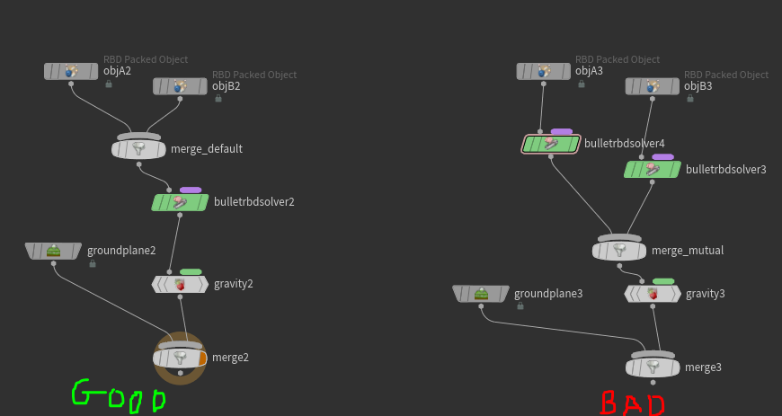
The image on the left shows the default setup: the bullet solver creates a mutual relationship by default and applies a reference to the same solver to both objects. As a result, one solver resolves both objA2 and objB2 in a single call, meaning it can handle the interactions between these objects internally, within its own substeps.
The image on the right shows a less likely, but still possible, setup. (A similar effect can be easily achieved with the setup on the left by simply enabling the "Solver Per Object" checkbox.) In this setup, there will still be mutual relationship between objA3 and objB3, but the objects will be referenced by different bullet solver instances. This, as we know, leads to the use of feedback loops, and we can observe the appearance of Feedback data on objA3, generated by the bullet solver for objB3. Now, instead of solving two objects simultaneously, each bullet solver instance will only solve one of the objects. First, one obA3 will be solved, then one ojbB3, with the calculated objA3 as a static collider. It will calculate the necessary impulse to be applied back to objA3 and attach this data to objA3, named Feedback. After this, Houdini will return the objects to their pre-solve state, preserving Feedback, and then go back in a loop: starting solving objA3, etc. It's easy to see the terrible results this approach leads to: essentially, we're prohibiting the bullet solver from using its own object interaction calculation mechanism and forcing the two bullet solvers to communicate through Houdini's shared mechanisms.
ANDThe only downside to the shared solver setup is that when traversing a node graph, the parameters on a node will only be calculated the first time during a single timestep traversal. Each subsequent calculation will simply return this stored data (as in the Share Data in One Timestep mode, discussed in Data Sharing). Therefore, varying any solver parameters for each individual object is not possible. However, it is still possible to customize the shared solver for different objects using auxiliary microsolvers, such as the switch solver and enable solver.
(example:sppnaqoban@HPaste(OBJ context))

Switch Solver
It's important not to confuse a Switch with a Switch Solver. We already know that a Switch is a node needed solely to determine the graph structure during traversal. A Switch Solver is a solver, and, as expected, it is triggered during the solving phase. This solver's functionality consists of running the functionality of one of its solver subdata. Subdata are counted by the insertion count; the required number can be specified either as a field in special switch data or in the switch solver itself.
Because the node graph does not correspond exactly to the data hierarchy, it is easy to make the following mistake:
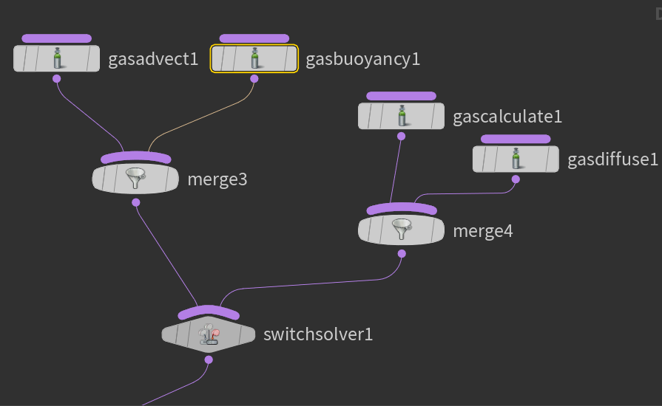
By the way, this method of connection is equivalent to the following, as we have already discussed earlier:
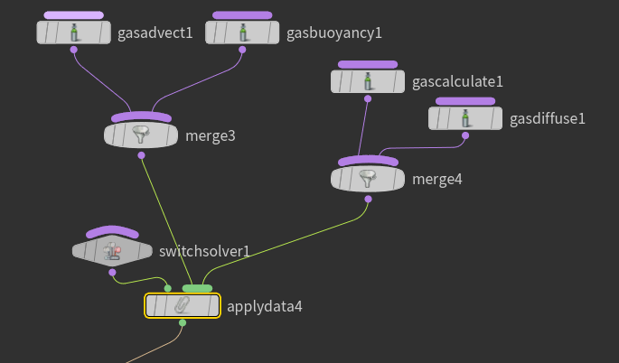
By constructing such a node structure, one might expect the switch solver to switch between groups of solvers within it. However, we now know how the node graph is evaluated, and we know that the join method shown above creates the same data structure as the following join:
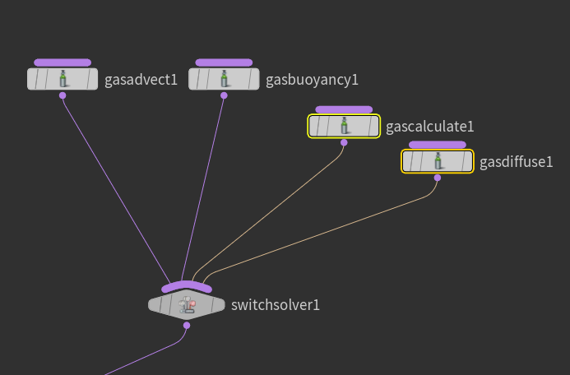
(assuming the normal operating mode of the graph).
Here is the structure they created
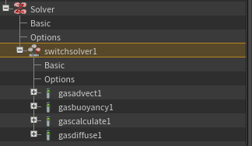
The sub-solvers gasadvect1 gasbuoyancy1 gascalculate1 and gasdiffuse1 will be sub-data of the switch solver, so the switch will choose from them whose functionality to run, depending on its switch value.
It's even easier to make this mistake when working with assets, such as the standard gas dissipate node:
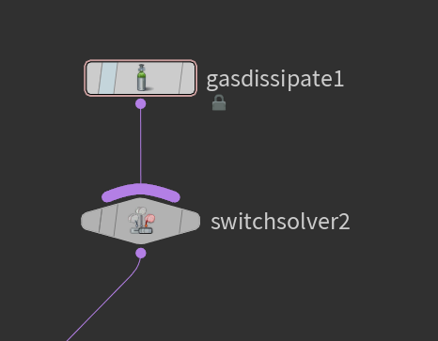
and the resulting data structure will be as follows:
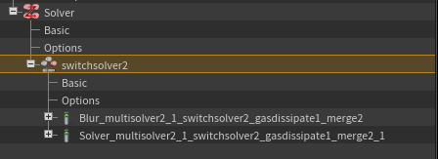
because the gas dissipate asset actually consists of two microsolvers, united by a merge:
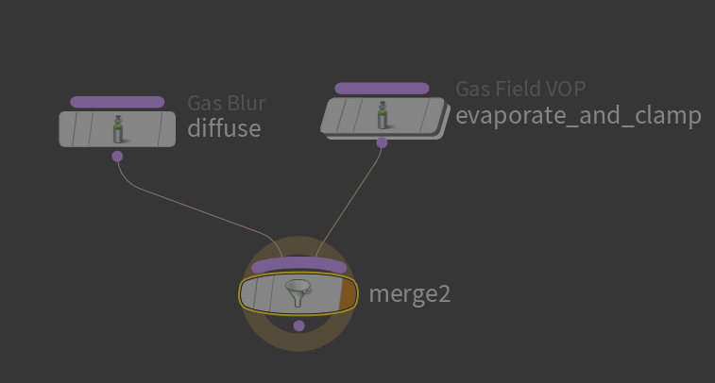.
If we want to group the sub-solvers of a switch solver in a way similar to the first picture, we need to use some intermediate sub-solver, for example a multiple solver, which, as we already know, is a solver container whose functionality as a solver is to run all the sub-solvers attached to it in a row.
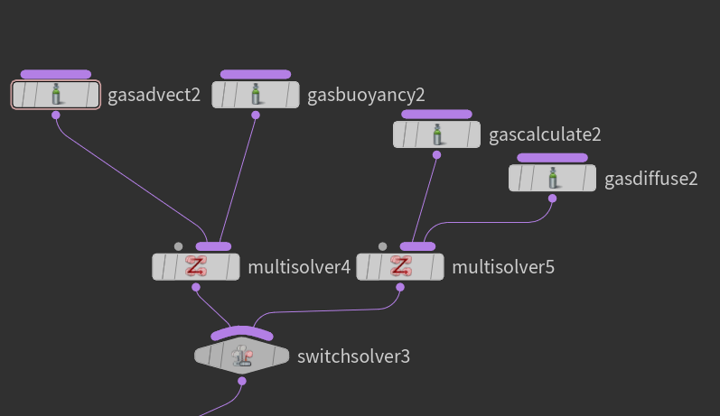
In the resulting data structure, we see that the subdata of switchsolver3 are now 2 multisolvers, and the switch will occur as expected between them.
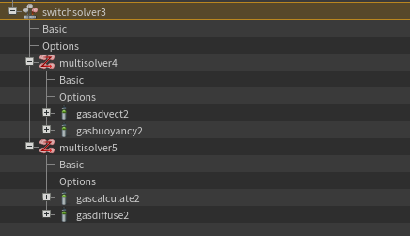

Enable Solver, Switch Solver. Customization of the general solver without the need to duplicate the main solver on objects.
We now know how important it is in some cases to have a common solver for objects that are interconnected by a relationship, which means that the same solver will be executed for all objects, without the possibility of changing and customizing them through parameters, similar to the following scheme:
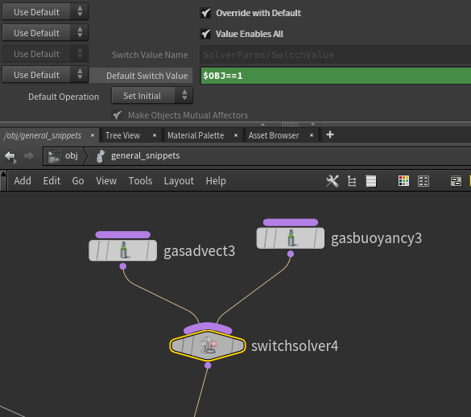
The expression will be calculated and written to the solver's data field only once during the node graph calculation stage. (As a reminder, a solver node with the "solver per object" checkbox unchecked behaves like a data node in Share Data In One Timestep mode.)
However, we can still customize the solver for different groups of simultaneously processed objects. The Enable Solver and Switch Solver, in addition to the most commonly used functionality of launching or selecting objects based on a default parameter written to the solver field from a node parameter, can also manipulate data.
For example, a switch solver can be switched by the value of some third-party data on an object, not on the solver, and an enable solver can be turned on by the presence/absence of data with a certain name on an object, or even by the presence/absence of geometric attributes in this data, if they are geometry.
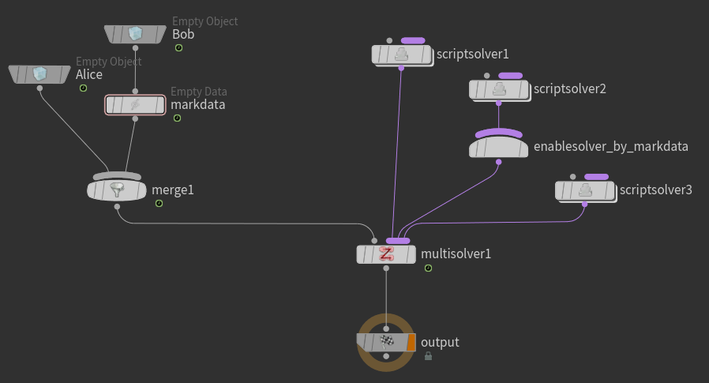
So in this example the solvers will be run with the following lists of objects:
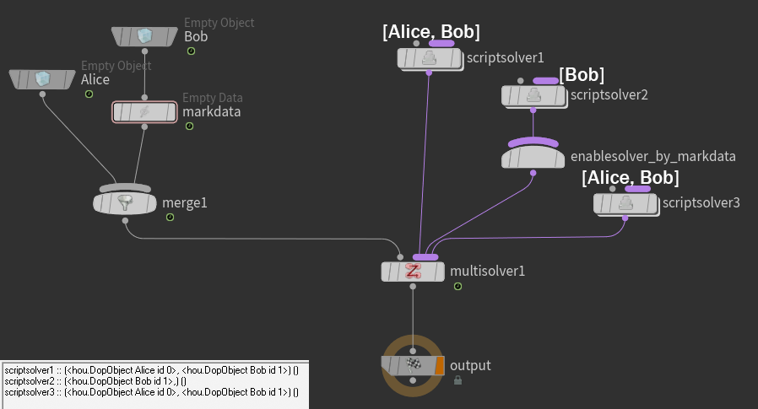
What can be seen from the list of objects output by solvers in the console?
(example:sppnuyedot@HPaste(OBJ context))

Similarly, you can use switch solver
In standard mode, the Switch Solver uses a special data type, SIM_SwitchValue, which stores the switch field in the Options record. In default mode, the Switch Solver searches the processed objects for a reference to switch data with the specified name and interprets the switch field as the ordinal number of the solver subdata to run for each object. It groups the objects for each of its sub-solvers and runs them for each corresponding group of objects.
Switch solver in value mode enables all does not interpret the switch field as a sub-solver ordinal, but instead runs all sub-solvers for objects with a switch field in the switch data that is not equal to zero.
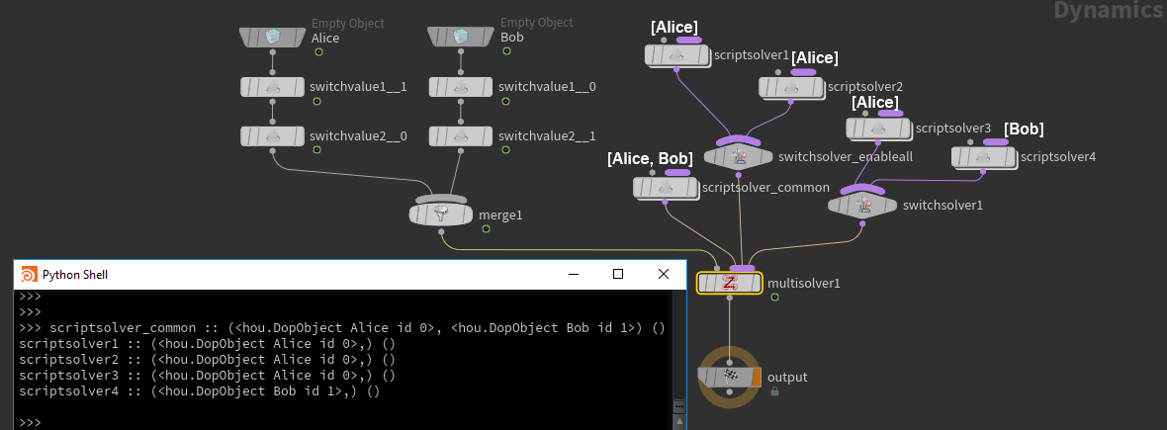
(example:spptezanol@HPaste(OBJ context))

However, these methods of specializing the behavior of a general solver only work for customizing solvers assembled from microsolvers; this method is not applicable to customizing the parameters of monolithic solvers, such as, say, the Bullet Solver. However, in the case of the Bullet Solver, all parameters that may vary from object to object can be specified both at the object level and at the level of geometric attributes.

